Genotype by environment interactions and phenotypic traits stability of EUCLEG faba bean collection

Dejan Sokolovic, Snezana Babic, Jasmina Radovic, Mirjana Petrovic (IKBKS), Natalia Gutierrez, Ana M. Torres (IFAPA), Ignacio Solís (Agrovegetal), Dirk Recheul, Mathias Cougnon (Gent University), Pertti Pärssinen (Boreal)

Abstract

Faba bean *(Vicia faba* L.) is one the most important cool season grain legume. The most common and traditional use of faba bean is for human food and for animal feed, especially for monogastrics, but also as protein component in ruminant herbage mixtures. According to FAOSTAT (2020) it has been growing on 2.58 million hectares worldwide with production over 5.43 million tons per year. On the European continent production declined significantly throughout the 20th century. Nevertheless, faba bean production is constantly increasing during last two decades in Europe and represents almost 30% of world fababean production, while China, which is the largest individual producer of faba bean in the world, produces more than 32%.

The strategic goal of the project EUCLEG is to increase global protein production and to reduce Europe and China’s dependency on protein imports by developing efficient breeding strategies and improving productivity and yield stability of faba bean, which is one of five species included in EUCLEG. Common breeding problem in faba bean is grain yield and its instability, which is a consequence of environmental effects and genotypes.

Phenology traits (as time of flowering and maturity) are very important in avoiding drought and hot periods for successful fertilisation, seed set and seed filling. Breeders are also united in the opinion that a compact plant habitus, a reduced vegetative lushness and lodging, and a synchronised generative growth with high number of pots per nodes are desirable traits.

The identification of faba bean germplasm suited to a number of different specific agro-ecological conditions is feasible in multi-location and multi-years trials with analyses of genotype x environment interactions.

Objectives of this research, as a part of EUCLEG, were to evaluate the diversity and stability of yield components traits in a collection of faba bean cultivars and populations and to examine their performances in different environments across Europe.

In EUCLEG, a collection of 220 faba bean cultivars and populations was studied. The number of accessions tested at each location was 100, among which 20 were standards. All accessions were evaluated at least two different locations. The experiment was conducted in three years (2018- 2020) in 4 representative European environments: Spain (Agrovegetal), Finland (Boreal), Belgium (Gent University) and Serbia (Institute for forage crops). Each combination of trial year and location was treated as a unique single environment. Finally, data were collected from 9 different environments, two from Spain, Finland and Belgium, and three from Serbia.

Trials were set-up in augmented experimental designs in row by column arrangement. Each trial was comprised of 140 plots in total, including repeated standards. The size of elementary plot was 5.6 m2 (4 rows 2 m long, 0,7 m between rows, 10 cm between plants). Trials were sown in spring and finished in summer months, except in Spain where, due to different climate, sowing was in autumn and the trials were finished in spring next year.

Fababean phenotyping in EUCLEG included 38 traits; in this article nine traits relevant for breeding are presented: time of flowering, time of maturity, plant height, plant branching, first pod height, pods per node, pods per flower, pod length and seeds per pod. All data were collected from plants in two central rows of the plot and are presented as average values per plot.

Statistical analyses were done by Progeno© software package and in R programme. Multi-environment trial data were subjected to Multi-trial linear mixed model analysis in Progeno for the estimation of variances. The standardized BLUPs values were generated by Progeno and analysed using Principal components analysis and correlations calculation in R. Genotype as main effect and genotype x environment interactions were visualised by “Which won where” GGE biplots for all investigated traits and mega-environments were detected. “Performance and stability” GGE biplots were developed to analyse values and stability of genotype traits within each mega-environment.

Significant differences among genotypes and environments for most of the investigated traits were detected. The average values of the traits were quite variable, which was expected according to the size and composition of the collection and the studied environments.

Estimation of variance components with a multi-trial mixed model revealed that variances of genotypes and their interactions with environments for most of the investigated traits were higher than variances originated from inexplicable sources (residuals). The highest variances of genotypes in comparison with residuals variances were detected for plant height, time of flowering, maturity, height of first pod, pod length and branching. All traits showed very high variances of interaction of genotypes and environments, but variances of maturity, plant height, branching, pods per node and pods per flower were higher than residual variances.

PCA showed that two main components described 56.2% of the variability. Trait vectors also confirmed that traits mentioned above are mostly responsible for this distribution of genotypes within Principal Components. The populations which showed the highest plants and the highest implantation of the first pods along with late maturity were small seeded genotypes from French breeding programs. Considering all environments, the small seeded Czech and German registered varieties Mistral and Merkur together with Merlin and Fanfare (used as standard varieties) showed the highest number of pods per node, which is one of the most important grain yield components.

Genotype by environment interactions analysis and GGE biplots showed that certain environments were frequently placed in the same groups, which enabled the construction of two mega-environments. Spanish and Serbian locations were put in a first mega-environment, while the second mega-environment consisted of Belgian and Finnish locations. Within each mega-environment the “performance and stability” GGE biplots identified which genotypes performed the best and which were the most stable in which environment. Accordingly, the best candidates for breeding and production were identified, as well as the most suitable trial sites.

Variability and characteristics which were detected in the EUCLEG collection of faba bean accessions provide a good basis for successful breeding and development of new cultivars which may increase EU and China faba bean production and reduce protein import.

1. Introduction

A balanced diet must include proteins as a key ingredient. Humans and animals who consume insufficient amounts of protein may develop health problems. The European and Asian continents are dependent on protein imports because protein production is not distributed equally throughout the world.That dependency results from the insufficient protein production in Europe and China and raising protein consumption worldwide (over 200 million tonnes/year). During last few decades, Europe has imported about 65% of its protein (de Visser et al., 2014) and the demand for protein is rising. The goal of the EU is to explore possibilities to further develop protein production in an economically and environmentally sound way (https://eur-lex.europa.eu­).

The strategic goal of the project EUCLEG is to reduce Europe and China’s dependency on protein imports by developing efficient breeding strategies for five the most commercially important grain and forage legumes. One of them is faba bean (*Vicia faba* L.). EUCLEG will try to increase global protein production and decrease dependency from imports by improving faba bean productivity and yield stability.

Faba bean *(Vicia faba* L.), also referred to as broad bean, horse bean or field bean depending on seed size and shape (Mínguez & Rubiales, 2021), is one the most important annual cool season grain legume (Bilalis et al., 2003) for animal and human consumption (Rubiales, 2010). It is the forth grain legumes in the world according to cropping areas, just behind pea, chickpea and lentil (FAOSTAT, 2018). According to FAOSTAT (2020) it has been growing on 2.58 million hectares worldwide with production over 5.43 million metric tons per year (Dhull et al, 2021-A). Even thought areas sown and total production of faba bean were constantly decreased last few decades, world statistical data shows that figures started to recover last few years.

On the European continent, production declined significantly throughout the 20th century to only 177.8 thousand ha in 2000. Nevertheless, faba bean production is constantly increasing during last two decades in Europe and represents almost 30% of world faba bean production. In China, which is the largest individual producer of faba bean in the world (more than 32% today), after constant and long lasting reduction of areas and production, figures started to grow recent years as well. (FAOSTAT, 2021)

The geographic origin of the faba bean is the Middle East (Cubero, 1974) and it has been cultivated in the early Neolithicum, at the very beginning of agriculture (Duc et al., 2015a). There were some claims that faba bean was domesticated even earlier, about 10,200 years BP (before present) in the Lower Galilee, Israel (Caracuta et al., 2015). First identified seeds which were presumed to be potential ancestor of faba bean were C-dated to 14 millennium BP (Caracuta et al., 2016). It is generally accepted that *Vicia faba* subsp. *paucijuga*, which is currently present in the Pakistan and eastern neighbouring region, is faba bean ancestral primitive form (Suso and Cubero 1986). Some archaeological records, showing that the first domesticated faba bean had small and rounded seeds similar to the *paucijuga* type (Torres et al., 2012), support the previous claims. Evolution of domesticated faba bean was run along with proliferation of different sizes and shapes of seeds, various levels of allogamy and differential faba bean winter tolerance. Spreading to Europe occurred via the Mediterranean coast and to China, which became secondary center of faba bean genetic diversity (Zong et al., 2009),via Mesopotamia (Cubero 2011).

*Vicia faba* is 2n species with 12 chromosomes. Although, the species which could be the wild ancestor of faba bean has not been found and its closest relativesare not so evident (Torres et al., 2012), its considered that species from the *Vicia narbonensis* complex according the morphological similarities could be the closest ones. Even though those species have more chromosomes (2n = 14), faba bean shows bigger nuclear DNA content (Meatloaf et al., 2017) and the largest described genome size among legumes, approximately 13,000 Mb (Johnstonet al., 1999). However, no successful stores were registered in interspecific crosses of faba bean and other species in *Vicia* genus (Torres et al., 2012; Caracuta et al., 2016).

Faba bean is partially allogamous species and outcrossing percentage varies from about few percent to almost total allogamy (85%) depending on both the genotype and the environmental conditions (geographical location), as well as the pollinator species and their activity at the time of flowering (Suso et al., 1999; Maalouf et al. 2002). The faba bean is an annual species adapted to cool conditions for the best development and consequently has advantage over soya bean in northern climates (Tomersgen et al., 2015). It has been regularly sown in the spring in northern latitudes and in the winter in warmer climate, covering latitudinal range from about 50oN to 40oS and altitudes from the sea level up to 3000m (Gnanasambandam et al., 2012).

The most common and traditional use of faba bean is as human food (Karkanis et al., 2018) especially in developing countries (mainly in Asia and Africa) and as animal feed in Europe (Dhull et al, 2022 B), especially for monogastrics, but also as protein component in ruminant diets with the potential to substitute soybean meal (Meng et al.,2021)

Faba bean contains a high concentration of proteins in the grains up to 34.5% of seed dry matter (Karkanis et al., 2018), even more than common food legumes (Bursin et al., 2011), containing 80% of globulins (Duc, 1997), as well as high amount of essential amino acids (lysine, arginine and leucine) up to 67 gkg-1 dry matter (Torres et al., 2012; Koivunen et al., 2016). Ripe seeds have a mineral content of 103 mg Ca, 6.7 mg Fe, 192 mg Mg, 421 mg P, 1062 mg K, 13 mg Na, and 3.14 mg Zn per 100 g of mass (USDA, 2021).

According to seed size there are three botanical varieties of faba bean: *major, minor* and *equina* ([Pietrzak et al., 2016](https://www.frontiersin.org/articles/10.3389/fpls.2018.01115/full#B149)) while the first domesticated material, characterized by very small and rounded seeds, belong to *paucijuga* type (Torres et al., 2012).

The effect of including of faba bean in a cropping system is positive in many ways. As result of *Rhizobium* symbiotic N fixation, faba bean stand may fix up to 200 kg N ha-1 (Neugschwandtner et al., 2015) and left residues into the soil, improving soil organic matter and nitrogen content and various soil physical properties (Salahin et al., 2013; Adekiya et al., 2017). Therefore yield performance of the subsequent or intercropped crops will be substantially improved (Duc et al., 2015) and use of the N fertilizer and N leaching reduced. On the other side intercropping faba bean and cereals has been shown to be also useful in faba bean disease reduction: chocolate spot (Hauggaard-Nielsen et al., 2008; Fernandez-Aparicio et al., 2010), ascochyta blight and broomrape (Fernandez-Aparicio et al., 2007).

However, even all these environment friendly characteristics of faba bean have high potential to mitigate factors from climate change, they are still poorly exploited in the modern agriculture.

Faba bean production in general faces a lot of different problems, like biotic stresses (diseases, pests and parasites), abiotic stresses (drought, high temperatures and frost), lack of adequate selective herbicides and therefore poor weed control. However, despite all that, thank to genetic improvement and breeding, especially in disease and parasites tolerance, world average faba bean yield per ha is quite improved today (2.1 tha-1) in comparison with period 1961 to 1964 (0.9 tha-1) (FAOSTAT 2021). Some modern cultivars adapted to contemporary agriculture may rich yield of 5 tha-1 (Duc, 1997).

Breeding of faba bean is process which try to develop genotypes that could solve different problems in production. One of major issue in faba bean, which is in common with many other legumes, is grain yield and its stability (Alghamdi et al., 2012; Flores et al., 2013). That characteristic of faba bean production could be one main reason for its low implementation in European agriculture practice and crop rotation (Cernay et al., 2015).The yield instability essentially is a consequence of environmental effects (Temesgen et al., 2015) and high abortion rate of fertilised ovules due to large number of flowers and flowering nodes and many fertilised ovules per flower, which together exceed the potential of the plant to feed and fill all existing seed sites. There are some data that only one quarter of ovules is developing into the faba bean seed (Rowlands, 1960).Therefore one of the most important breeding criteria should be the seed/flower ratio.

Stable yield and production in faba bean is also connected with adequate plant symbiosis with *Rhizobium leguminosarum* to develop nitrogen-fixing root nodules, as well as on the stable wild bees’ population as pollinators to ensure both optimal seed set and outcrossing rates (O’Sullivan and Angra, 2016).

Meeting the protein demand of a developing human population represents a breeding challenge not only from the faba bean yield perspective but also from the quality point of view. Lot of breeding activities are directed toward increasing of seed protein content and reducing the concentrations of anti-nutritional factors such as vicine/convicine, trypsin inhibitors and tannins (Crepon et al., 2010; Burstin et al., 2011; Multary et al., 2015).

Seed size is one of the most important breeding topics since smaller seed size (minor type) is better from farmer’s economical point of view at crop establishment and in the final yield.

During long breeding history of this species diverse genetic pool was developed, consisted of local landraces, populations in open pollination or cultivars (Duc et al., 2010). Allogamous nature of faba bean allows development of synthetics and populations cultivars and hybrids which,unfortunately, still can’t be produced commercially (Palmer et al., 2011). The degree of outcrossing determines level of heterosis, which usually improve yield, yield stability and tolerance to abiotic stresses (Gasim and Link 2007).

Lot of faba bean genetic resources (cultivars and landraces) nowadays are available for cropping in different environments and for further breeding (Liu and Hou 2010). Such a material is essential for creation of genotypes with new or improved characteristics for changing growing conditions,

including climate change and intense disease occurrence. But it is impossible to use germplasm without solid information about its genetic value and genetic diversity, which can be revealed by phenotypic and molecular evaluation of faba bean genotypes. Various molecular genetic marker systems have been used to assess the genetic diversity and relationships between accessions in faba bean collections with or without parallel phenotypic evaluation of accessions (Torres et al., 1993; Zeid et al., 2003; Terzopoulos and Bebeli, 2008 – referenca za paradajz; Oliveira et al., 2016; Göl et al., 2017; Kaur et al., 2014; Sallam et al., 2016a,b; Elshafei et al., 2019; Carrillo-Perdomo et al., 2020).

The identification of faba bean germplasm suited to a number of different specific agro-ecological conditions with specific attention for resistance to combinations of biotic and abiotic stresses is feasible in multi-location and multi-years trials with analyses of genotype x environment interactions.

The structure of G × E interaction is an important part of the plant breeding programs since multi-environment trials mean performance is often considered as an average of the genotype over years and locations. GGE biplot (genotype plus genotype-by-environment interaction) eliminates the statistical effect of the environment and concentrates on genotype evaluation and traits stability. All that can be performed with higher accuracy, since “the noise” produced by the environment is eliminated. A secondary goal of the GGE biplot is to determine the target region and possibility definition of different mega-environments (Yan et al. 2000).

The aim of this study was to perform multi-environment and multi-year trail using collection of 220 faba bean accessions to evaluate stability of yield component traits. During three years four representative European agroecological areas were implemented in the research process with the aim: а) to evaluate the diversity and stability of yield component traits in collection of faba bean cultivars and populations and possibility for future breeding, б) find the accessions suitable for each agroecological environment across the Europe.

2 Matherials and methods

2.1 Faba bean diversity panel

TODO: 1. Tačan naziv svake osobine ( dugačak naziv i skraćenica)

Collection of 220 faba bean accessions defined within Eucleg project (Breeding forage and grain legumes to increase EU՚s and China՚s protein self-sufficiency – www.eucleg.eu) was studied. Accessions are conserved in four locations: Centro Nacional de Recursos Fitogenéticos (ESP004); Junta de Andalucía. Consejería de Agricultura y Pesca. Instituto Andaluz de Investigación y Formación Agraria, Pesquera, Alimentaria y de la Producción Ecológica Centro Alameda del Obispo (ESP046); UMR1347 Agroecology, Plant Biology and Breeding, INRAE Dijon (FRA043) and Nordic Genetic Resource Center (SWE054). All accessions are categorised in 4 basic botanical types according to seed characteristics: major, minor, equina and paucijuga as well as 4 transitional: equina-major, equina-minor, major-equina and minor-paucijuga. These accessions originate from 42 countries and 4 regions (Europe, Africa, Asia and Americas). (**Figure** xxx, Supplementary Table xxx)

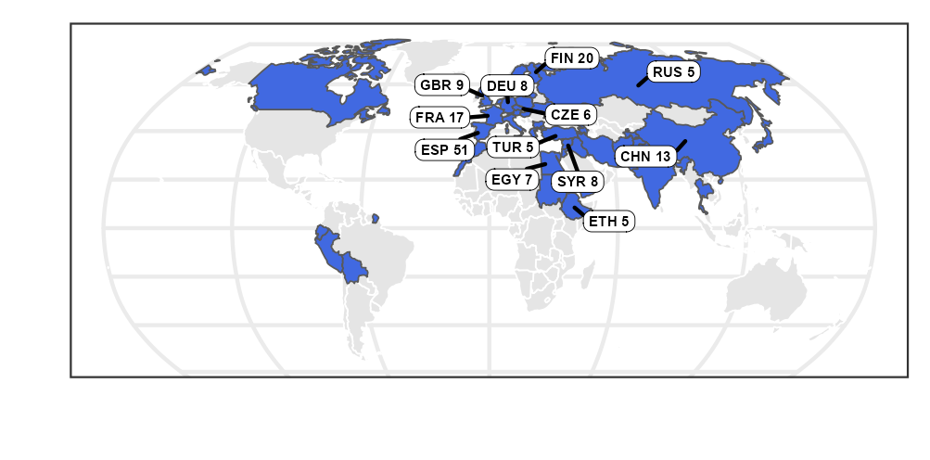

Figure xxx: The map displays the origine of 220 faba bean accessions, as well as collection countries with more than five accessions.

2.2 Experiment locations and designs

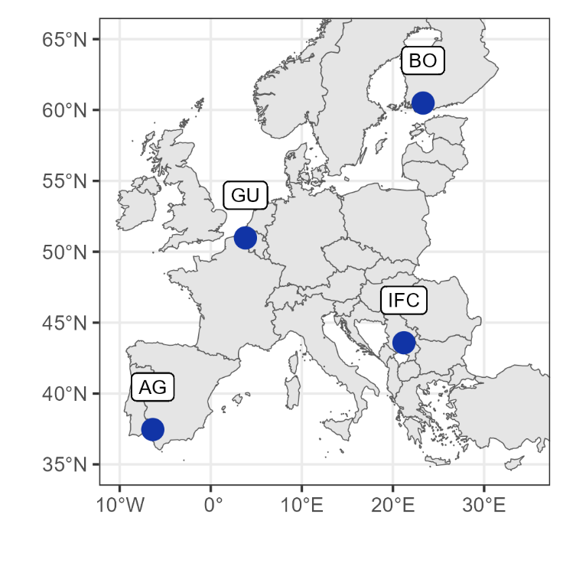

Figure xxx: The experiment locations are indicated by blue circles. AG (Agrovegetal) – Spain; IFC (Institute for forage crops Kruševac) – Serbia, GU (Gent University) – Belgium, BO (Boreal) – Finland.

The maps presenting at Figure 1 and 2 was generated using packages rnaturalearth (v0.3.2 Massicotte P, South A 2023), eurostat(v.3.8.2. Lahti et al., 2017)

The experiment was conducted in three years (2018 - 2020) in the network of field testing sites, covering 4 representative European biogeographic regions: continental, mediterranean, atlantic and boreal (<https://www.eea.europa.eu/data-and-maps/figures/biogeographical-regions-in-europe-1>) (Table xxx).

Table xxx. The experiment locations with GPS positions, climate and time frame

|  |  |  |  |  |  |  |  |  |
| --- | --- | --- | --- | --- | --- | --- | --- | --- |
| Institute | Country | Location | Acronim | Latitude | Longit-ude | Altit. (m asl) | Climate type | Trials duration |
| Agrovegetal | Spain | Escacena Del Campo | AG | 37°46'N | 6°36'W | 67 | Mediterr-anean | 2018-2020 |
| Boreal | Finland | Jokioinen | BO | 60°49'N | 23°30'E | 39 | boreal | 2018-2019 |
| Gent University | Belgium | Melle | GU | 50°98’N | 3°81’E | 11 | atlantic | 2018-2019 |
| Institute for forage crops | Serbia | Globoder,  Kruševac | IFC | 43°58’N | 21°20’E | 149 | continental | 2018-2020 |

Each combination of trial year and location was treated as a unique single environment. Finally, data were collected from 9 different environments (location-by-year), two from Spain, Finland and Belgium, and three from Serbia. Therefore, there were 9 field trials in total. Each environment got acronim composed of instituts acronim and experimental year. To obtain enough seed for all trails, seed of all accessions was multiplied in isolation, in Serbia, in insect proof cages to exclude outcrossing.

**Table xxx**. Parameters for the faba bean trails in each environment.

|  |  |  |  |  |  |  |  |  |  |
| --- | --- | --- | --- | --- | --- | --- | --- | --- | --- |
| Environments | AG18 | AG19 | IFC18 | IFC19 | IFC20 | BO18 | BO19 | GU18 | GU19 |
| Number of acc |  |  |  |  |  |  |  |  |  |
| 1 plot | 80 | 80 | 79 | 79 | 79 | 80 | 78 | 80 | 77 |
| 2 plot | 15 | 15 | 15 | 15 | 15 | 15 | 15 | 15 | 15 |
| 6 plot | 5 | 5 | 5 | 5 | 5 | 5 | 5 | 5 | 5 |
| in total | 100 | 100 | 99 | 99 | 99 | 100 | 98 | 100 | 97 |
| number of plots | 140 | 140 | 139 | 139 | 139 | 140 | 138 | 140 | 137 |
| rows x columns | 14x10 | 14x10 | 14 x 10 | 14 x 10 | 14 x 10 | 14 x 10 | 14 x 10 | 14x10 | 14x10 |
| plot size | 2x2,1m | 2x2,1m | 2x2,8m | 2x2,8m | 2x2,8m | 2x2m | 2x2m | 2x2m | 2x2m |
| Number of rows per plot | 4 | 4 | 4 | 4 | 4 | 3 | 3 | 4 | 4 |
| Distance between rows within plots | 0,7 m | 0,7 m | 0,7m | 0,7m | 0,7m | 0,7m | 0,7m | 0,5m | 0,5m |
| Distance between rows between plots | 1,5 m | 1,5 m | 0,7 m | 0,7 m | 0,7 m | 0,7m | 0,7m | 0,5m | 0,5m |
| Sowing depth (in cm) | 3 cm | 3 cm | 3 cm | 3 cm | 3 cm | 6 cm | 6 cm | 5 cm | 5 cm |
| Sowing density (seeds m2) | 20 | 20 | 14 | 14 | 14 | 12 | 12 | 14 | 14 |
| Sowing date | 2018-11-16 | 2018-11-16 | 2018-04-25 | 2019-03-27 | 2020-03-03 | 2018-06-02 | 2019-06-02 | 2018-05-28 | 2019-04-04 |

Each field trial was set-up using augmented experimental design in row by column arrangement (14 x 10). And each field trail comprised 20 identical checks (standards). Standards were sown 15 in two replications and 5 in six replications, 200 test entries only in one repetition. (Table 2)

Except 5 cultivars (Mistral, Merkur, Merlin, Fanfare and Baraca) all other entries were landraces.

Fertilizer was applied initially in basic cultivation within the local common practice in all location, as well as optional herbicide and insecticide treatments. Since evaluation of fungal diseases was planned in the trials, in all locations fungicide treatments were excluded. Trials in all years were sown in spring and finished in summer months, except in the Spain where due to different climate and mild winter, sowing was in the autumn and the trials were finished in spring next year.

**2.3 Phenotyping**

In the faba bean phenotyping trials in Eucleg, 32 traits were evaluated. In this article 9 traits relevant for breeding of faba bean, which affect the final yield, were presented: full flowering date (50% fully flowered plants, days from plants emergence), maturity date (90 to 100% of pods have been ripened, days from plants emergence), plant height (measured near maturity, from the soil to the top of the highest steam, cm), plant branching (number of branches on basal node), height of first pod (cm), number of pods per node (measured on 5 nodes on plant main stem), number of pods per flower (calculated trait, number of pods per node divided with number of flowers per node), pod length (cm, measured on 10 pods from nodes on plant main stem) and number of seed per pod (in 10 representative pods per plant).

All data were collected from plants in two central rows of the plot and presented as average values.

All genotypes are categorised in four main and for traditional botanical type (Suplementary table 1): Paucijuga, Minor-Paucijuga, Minor, Equina-Minor, Equina, Major-Equina, Major, Equina-Major. Due to analyses, transitional seed types are merged with main types which was presented as four groups (Figxx, - Figxx).

2.4 Statistical analysis

All data analyses were performed in R (R Core Team 2022)  and by Progeno© database and software package (citat). Prior the main analysis, data were subjected to graphical homogeneity check of each environment separately with box plots, histograms, scatter plots and heat maps.

[ BLUP – ovi se korist za cluster analysis i za PCA ]

The standardized BLUP (Best Linear Unbiased Prediction) values of genotype effects of 9 morphological traits, which takes into account known or estimated variances (Liu et al., 2008) were generated by Progeno© database and software package.

**Deskriptivna:** Data were expressed as descriptive statistical parameters mean, minimum, maximum, range, standard deviation, standard error and coeficient of variation.

**Estimation of variance:** Multi-environment trial (MET) data were subjected to Multi-trial linear mixed model analysis in Progeno© for variance evaluation. The multi trial analysis always performs a trial connectivity analysis since analyze of these trials together needs we are sure that the trials are fully connected by common accesions (standards).

The variance parameters have been estimated by the Restricted Maximum Likelihood or REML procedure. Firstly it has to be indicated that the likelihood has converged and that the estimation procedure has finished normally and that resulting variance components effectively maximize the likelihood function.

**Botanical Types:** The effect of Botanical Types on 9 response variables was analyzed using linear mixed effect models with lmer function from lme4 package (v1.1.31; Bates et al., 2015). We considered Botanical Type (Paucijaga, Minor, Equina and Major) as fixed efects and Environmet and Genotype as random effects. For each response variables the model’s intercept, corresponded to Botanical Type paucijuga. The package lmerTest (v3.1.3;Kuznetsova et al. 2017) was used to approximate degrees of freedom and calculate p-values for the fixed exect.

**Correlations:** The Pearson correlation coefficients among the nine phenotypic traits and among environments for each trait were performed using the rcorr function from Hmisc package (v5.0.1; Harrell, 2023). The correlation were visualised using the ggcorrplot package (v0.1.4; Kassambara, 2022).

**GGE Biplot model:** The biplot is a popular data visualization tool introduced by Gabriel, K. R. (1971), because it represents observations and variables in a single graph. Biplot graphical analysis allows the detection of groups in the observations while also showing the dispersion and correlations between variables or columns (Hongyu et al., 2014; Gauch, 2006). GGE Biplot analysis (Yan et al., 2000) displays both genotype main effects (G) and genotype x environment effects (GE) from multi-environment trials (MET). Plant breeders have found GGE Biplots very useful in mega-environment analysis (CT2, CT3) and genotype evaluation (CT1, CT4). Although the GGE biplot does not separate genotype effect (G) from the genotype x environment (GxE) interaction, in (CTF1) it was concluded that the GGE is equal to or superior to the AMMI proposed by (Gauch, 2006) in three main aspects of genotype by environment data (GED) analysis: mega-environment analysis, genotype evaluation, and test-environment evaluation.

The GGE Biplot is based on decomposing the data matrix Y (which contains rows representing genotypes and columns representing environments) by singular value decomposition (SVD) into principal components with as

where is the mean performance of genotype in enviroment *j*, is the mean value of enviroment *j*, and *t* is the number of principal components. is genotype scores matrix,  is the environment scores matrix, are singular values. The model constraints are: (i), (ii) matrices  and are orthonormal (CTF1).

The GGE Biplot is constructed using the first two PCs. The genotype coordinates are while the coordinates of envionments are .The exponent , with is used to rescale the genotype and environment scores to enhance the visual interpretation of the biplot. “Cultivar focused” scaling has the “environment focused” scaling has and for  we have “symetric scaling” (Yan, 2002).

Mega – environment analysis

Mega – enviroment is a group of locations that constantly share the best set of genotypes across years (Yan and Rajcan 2002). So we need data from multiple years at the same location in order to decide which locations can be grouped into mega-environments.

For each of nine traits, we conducted mega-environment analysis ("which-won-where" pattern of the GGE Model) and genotype evaluation ("mean vs. stability" pattern of the GGE Model) based on 220 genotypes in nine environments.

The mega – enviroment analysis is performed using the polygon view (which-won-where view) of the GGE Biplot (Yan et al., 2000). Which-won-where view contains an irregular polygon whose vertices are genotypes, such that all other genotypes are located in its interior. For each side of the polygon, we construct a line that starts at the origin and intercepts the polygon side at the right angle. These lines represent hypothetical environments in which two genotipes at the end of the corresponding side perform equally.

The lines radiating from the origin divide the biplot into sections, and there is a vertex (genotype) for each section that had the best yield performance in the environments contained in that section, which is called a mega-environment. (CTF2). If environments are located in different sectors, this means that different genotypes won in different environments, so the original set of environments can be divided into two or more mega – enviroments.

**Genotype evaluation**

Genotype evaluation makes sense only for a specific mega-environment, so the genotype evaluation is performed for each mega-environment separately using the Average Environment Condition (AEC) view of the GGE Biplot (Yan 2001), also called the "Mean vs. Stability" view.

The AEC has two axes. The apscisa, or average environment axes (AEA), passes through a biplot origin and an average environment point, which is located at the mean of PCA1 and PCA2 scores. It has a single arrow that is pointing toward a greater mean performance for a selected trial. The genotype performance is ranged according to its projection on the AEA. The average environment axes represent the main effect of a genotype (G contribution to the G+GE model).

The second (ordinate) axis passed through the origin and is perpendicular to the apcisa. Ordinate measures the stability of a genotype, and it approximates the genotype contribution to genotype by enviroment interactions. Stable genotypes tend to have smaller projection lengths on the ordinate, so they are closer to the average environment axes. The unstable genotypes have larger projections, so they are further away from the apcisa.

The ideal genotype is a hipothetic genotype, represented by a small circle, and it is located on the AEC abscissa. The ideal genotype has the highest performance, and it is absolutely stable as it is located on the AEC apsica (CT5). All other genotypes can be ranked based on their distance from the ideal genotype.

Genotype as main effect and genotype x environment (GE) interactions were analysed and visualised by GGE biplots for all investigated traits separately as described by Yan and Kang (2003). Results are presented in “Which won where” GGE biplots (Yan et al., 2007) representing effective graphic tool for mega-environment analysis and in Average environment coordination (AEC) GGE view (Yan et al., 2000) to analyse both performance and stability within each mega-environment.

**Clustering:** Best linear unbiased predictors (BLUP) obtained for all the traits are used to perform Hierarchical Cluster Analysis. The genotypic distance matrix, based on a scaled matrix of BLUP-s with 220 rows (genotypes) and 9 columns (tirals), was constructed using euclidean distance measure. The phenotypic distance matrix for nine traits was constructed based on the Pearson correlation coefficient. Two dendrograms, based on the genotypic and phenotipic distance matrix, were constructed using the complete linkage method with dendextend package (v1.17.1; Tal 2015). Hierarchical Cluster Analysis Heatmap were created using the heatmap.2 function from gplots package (v3.1.3; Warnes et al., 2015). Average interclass and intraclass distances were computed using clv package (v0.3.2.2; Nieweglowski, 2015).

**PCA:** We performed principal component analysis (PCA) based on BLUPS to visualize the relationships between the nine phenotypic traits and 220 genotypes. Also, the PCA was used to further examine the results obtained by the Hiearihal Clustering Method in section 3.4. In order to visualize differences between four botanical types, we conducted a Principal Components Analysis based on standardized BLUPS of those genotypes for which Botanical Type was known. All PCA analyses were done using prcom function from R Stats Package.

3 Resultst

3.1 Descriptive statistical analysis

All trails, exepte of Spain localities, were established in spring of 2018, 2019, and 2020. Because of the different climatic conditions in Spain (environments AG18 and AG19), sowing occurred in the autumn and the trials were completed in the spring of the following year. Data of two phenological traits were collected and analysed.

**Number of days to 50% flowering** in all environments varied between genotypes by 80 days, from minimum of 28 days (IFC20) to maximum of 108 days (AG18), while **matyrity** varied by almost 116 days between the earliest genotypes (68 days; IFC19) and the latest genotypes (184 days; AG18). As a result of autumn sowing, Spain required longer average times than other environments for full flowering (80.2 - 90.4 days) and ripening (156 -166 days). Kruševac location, year 2019 (IFC19), had the earliest environment with spring sowing, and all accessions were ripened after an average of 78 days.

CV (coefficient of variation) of DFF exceeded 13% in 5 environments (max values of 18.1 was in BO19), whereas number of days to maturity variability was obviously more even across environments (CVs below 10%).

**Table** xxx**.** Descriptive statistics (mean, minimum, maximum, range, standard deviation, standard error and coeficient of variation) for 9 agronomic traits of faba bean acessions in nine environments

|  |  |  |  |  |  |  |  |  |  |
| --- | --- | --- | --- | --- | --- | --- | --- | --- | --- |
| Trait | number of days to 50% flowering - DFF | | | | | | | | |
| Environments | AG18 | AG19 | BO18 | BO19 | GU18 | GU19 | IFC18 | IFC19 | IFC20 |
| mean | 90.4 | 80.2 | 40.8 | 53.3 | 40 | 54.7 | 52.6 | 38.8 | 36.2 |
| sd | 6.61 | 7.2 | 5.45 | 9.65 | 5.41 | 2.66 | 4.45 | 5.69 | 5.41 |
| cv | 7.3 | 9 | 13.4 | 18.1 | 13.5 | 4.9 | 8.5 | 14.7 | 14.9 |
| se | 0.45 | 0.49 | 0.37 | 0.65 | 0.36 | 0.18 | 0.3 | 0.38 | 0.36 |
| min | 68 | 71 | 32 | 41 | 30 | 49 | 41 | 29 | 28 |
| max | 108 | 106 | 55 | 78 | 56 | 63 | 69 | 60 | 51 |
| range | 40 | 35 | 23 | 37 | 26 | 14 | 28 | 31 | 23 |

|  |  |  |  |  |  |  |  |  |  |
| --- | --- | --- | --- | --- | --- | --- | --- | --- | --- |
| Trait | Number of days to maturity | | | | | | | | |
| Environment | AG18 | AG19 | BO18 | BO19 | GU18 | GU19 | IFC18 | IFC19 | IFC20 |
| mean | 166 | 156 | 97 | 103 | 87 | 109 | 97 | 78 | 95 |
| sd | 6.68 | 6.62 | 10.06 | 3.62 | 4.18 | 5.4 | 7.93 | 7.66 | 6.29 |
| cv | 4 | 4.3 | 10.4 | 3.5 | 4.8 | 4.9 | 8.1 | 9.8 | 6.6 |
| se | 0.45 | 0.45 | 0.68 | 0.24 | 0.28 | 0.36 | 0.53 | 0.52 | 0.42 |
| min | 153 | 144 | 81 | 94 | 83 | 104 | 87 | 68 | 78 |
| max | 184 | 170 | 114 | 112 | 106 | 119 | 116 | 104 | 109 |
| range | 31 | 26 | 33 | 18 | 23 | 15 | 29 | 36 | 31 |

|  |  |  |  |  |  |  |  |  |  |
| --- | --- | --- | --- | --- | --- | --- | --- | --- | --- |
| Trait | Plant height | | | | | | | | |
| Environment | AG18 | AG19 | BO18 | BO19 | GU18 | GU19 | IFC18 | IFC19 | IFC20 |
| mean | 76.7 | 93.3 | 52.4 | 34.4 | 69.2 | 66.2 | 72.3 | 80.6 | 70.7 |
| sd | 13.7 | 20.74 | 9.67 | 5.99 | 16.59 | 16.41 | 16.33 | 15.9 | 15.55 |
| cv | 17.9 | 22.2 | 18.4 | 17.4 | 24 | 24.8 | 22.6 | 19.7 | 22 |
| se | 0.92 | 1.4 | 0.65 | 0.4 | 1.12 | 1.11 | 1.1 | 1.07 | 1.05 |
| min | 47 | 46 | 33 | 25 | 36 | 33 | 43 | 40 | 37 |
| max | 121 | 154 | 88 | 48 | 107 | 111 | 118 | 133 | 114 |
| range | 75 | 109 | 55 | 23 | 70 | 78 | 75 | 93 | 76 |

|  |  |  |  |  |  |  |  |  |  |
| --- | --- | --- | --- | --- | --- | --- | --- | --- | --- |
| Trait | Number of Branches | | | | | | | | |
| Environment | AG18 | AG19 | BO18 | BO19 | GU18 | GU19 | IFC18 | IFC19 | IFC20 |
| mean | 4.9 | 4.05 | 3.61 | 2.02 | 1.78 | 4.02 | 4.39 | 2.72 | 4.21 |
| sd | 1.8 | 1.41 | 1.53 | 1.17 | 0.43 | 1.41 | 1.67 | 0.81 | 1.08 |
| cv | 36.6 | 35 | 42.4 | 57.8 | 24.2 | 35 | 38 | 30 | 25.7 |
| se | 0.121 | 0.095 | 0.103 | 0.079 | 0.029 | 0.095 | 0.112 | 0.055 | 0.073 |
| min | 2 | 2 | 1 | 1 | 1 | 2 | 1 | 1 | 2 |
| max | 13 | 10 | 10 | 5 | 3 | 8 | 9 | 5 | 7 |
| range | 11 | 8 | 9 | 4 | 2 | 7 | 8 | 4 | 5 |

|  |  |  |  |  |  |  |  |  |  |
| --- | --- | --- | --- | --- | --- | --- | --- | --- | --- |
| Trait | Height of first pod in cm | | | | | | | | |
| Environment | AG18 | AG19 | BO18 | BO19 | GU18 | GU19 | IFC18 | IFC19 | IFC20 |
| mean | 34.4 | 31.2 | 28.6 | 16.1 | 27.3 | 23.7 | 27.4 | 27.7 | 20.9 |
| sd | 12.07 | 8.89 | 7.64 | 4.96 | 6.96 | 7.05 | 7.11 | 10.14 | 5.75 |
| cv | 35.1 | 28.5 | 26.8 | 30.8 | 25.5 | 29.7 | 26 | 36.6 | 27.5 |
| se | 0.814 | 0.6 | 0.515 | 0.335 | 0.469 | 0.475 | 0.48 | 0.683 | 0.388 |
| min | 16 | 14 | 11 | 4 | 13 | 10 | 13 | 9 | 10 |
| max | 79 | 65 | 49 | 28 | 43 | 44 | 60 | 59 | 40 |
| range | 62 | 51 | 38 | 24 | 31 | 33 | 47 | 50 | 29 |

|  |  |  |  |  |  |  |  |  |  |
| --- | --- | --- | --- | --- | --- | --- | --- | --- | --- |
| Trait | Number of pods per flower | | | | | | | | |
| Environment | AG18 | AG19 | BO18 | BO19 | GU18 | GU19 | IFC18 | IFC19 | IFC20 |
| mean | 0.202 | 0.235 | 0.424 | 0.182 | 0.325 | 0.495 | 0.436 | 0.382 | 0.381 |
| sd | 0.043 | 0.075 | 0.187 | 0.092 | 0.096 | 0.183 | 0.184 | 0.138 | 0.102 |
| cv | 21.3 | 32 | 44.1 | 50.4 | 29.6 | 37 | 42.1 | 36.2 | 26.7 |
| se | 0.0029 | 0.0051 | 0.0126 | 0.0062 | 0.0065 | 0.0123 | 0.0124 | 0.0093 | 0.0069 |
| min | 0.12 | 0.13 | 0.14 | 0.06 | 0.11 | 0.18 | 0.11 | 0.14 | 0.16 |
| max | 0.32 | 0.53 | 0.85 | 0.41 | 0.61 | 1 | 0.94 | 0.76 | 0.73 |
| range | 0.21 | 0.4 | 0.71 | 0.35 | 0.5 | 0.82 | 0.82 | 0.63 | 0.57 |

|  |  |  |  |  |  |  |  |  |  |
| --- | --- | --- | --- | --- | --- | --- | --- | --- | --- |
| Trait | Number of pods per node | | | | | | | | |
| Environment | AG18 | AG19 | BO18 | BO19 | GU18 | GU19 | IFC18 | IFC19 | IFC20 |
| mean | 1.16 | 1.22 | 1.4 | 0.47 | 1.43 | 1.76 | 1.73 | 1.92 | 1.77 |
| sd | 0.162 | 0.21 | 0.306 | 0.26 | 0.782 | 0.629 | 0.36 | 0.386 | 0.37 |
| cv | 14 | 17.2 | 21.9 | 55.1 | 54.5 | 35.8 | 20.8 | 20.2 | 20.9 |
| se | 0.011 | 0.014 | 0.021 | 0.018 | 0.053 | 0.042 | 0.024 | 0.026 | 0.025 |
| min | 1 | 1 | 0.71 | 0.2 | 0.2 | 0.57 | 1 | 1.11 | 1.12 |
| max | 1.78 | 2.07 | 2.4 | 1.22 | 3.95 | 4.12 | 2.89 | 2.98 | 3.21 |
| range | 0.78 | 1.07 | 1.69 | 1.02 | 3.75 | 3.55 | 1.89 | 1.87 | 2.09 |

|  |  |  |  |  |  |  |  |  |  |
| --- | --- | --- | --- | --- | --- | --- | --- | --- | --- |
| Trait | Pod length in cm | | | | | | | | |
| Environment | AG18 | AG19 | BO18 | BO19 | GU18 | GU19 | IFC18 | IFC19 | IFC20 |
| mean | 7.29 | 9 | 5.39 | 5.62 | 6.22 | 6.18 | 6.18 | 6.8 | 8.56 |
| sd | 2.75 | 2.24 | 0.81 | 1.11 | 0.9 | 1.12 | 1.08 | 1.33 | 2.3 |
| cv | 37.7 | 24.9 | 15 | 19.7 | 14.4 | 18.1 | 17.5 | 19.6 | 26.9 |
| se | 0.185 | 0.151 | 0.054 | 0.075 | 0.06 | 0.076 | 0.073 | 0.09 | 0.155 |
| min | 1 | 5.2 | 3.34 | 3.65 | 4.48 | 4.06 | 3.83 | 3.44 | 4.42 |
| max | 18.38 | 17.73 | 8.94 | 12.2 | 8.3 | 10.2 | 9.6 | 10.05 | 14.99 |
| range | 17.38 | 12.53 | 5.6 | 8.55 | 3.82 | 6.14 | 5.77 | 6.61 | 10.57 |

|  |  |  |  |  |  |  |  |  |  |
| --- | --- | --- | --- | --- | --- | --- | --- | --- | --- |
| Trait | Number of seed per pod | | | | | | | | |
| Environment | AG18 | AG19 | BO18 | BO19 | GU18 | GU19 | IFC18 | IFC19 | IFC20 |
| mean | 2.44 | 3.19 | 2.27 | 2.52 | 2.95 | 2.71 | 3.32 | 3.5 | 3.71 |
| sd | 0.75 | 0.8 | 0.71 | 0.47 | 0.55 | 0.54 | 0.53 | 0.59 | 0.72 |
| cv | 30.7 | 25.1 | 31.2 | 18.8 | 18.8 | 20 | 16 | 16.8 | 19.4 |
| se | 0.05 | 0.054 | 0.048 | 0.032 | 0.037 | 0.036 | 0.036 | 0.04 | 0.049 |
| min | 1 | 1.87 | 1 | 1.3 | 1.3 | 0.96 | 2 | 2 | 2.2 |
| max | 4.35 | 8.33 | 4 | 3.5 | 4.14 | 3.9 | 4.5 | 4.7 | 8.04 |
| range | 3.35 | 6.47 | 3 | 2.2 | 2.84 | 2.94 | 2.5 | 2.7 | 5.84 |

In AG19 maximum plant height was determined - 154 cm, where also highest average values for this trait were detected (93.3 cm). Shortest plants were detected in the BO19 environment, reached only 25 cm in average for all accessions, obviously due to unfavourable weather conditions on that location during growing season. Variability of this trait was high in all environments exceeding 17.4% for coefficient of variation. Average values of **branching** were very low in the environment GU18 (1.78) and BO19 (2.02). Even branching was quite low in the environment BO19 variability was the highest, CV was almost 60%. Single plants developed maximaly 13 branches in Spain (AG18), in the same environment the hghiest mean values was calculated – 4.9.

Height of the first pod had the highest mean and maximum value at the AG18 environment (34.4 cm and 79 cm, respectively). The environment BO19 recorded the lowest value of this characteristic, with a mean of 16.2 cm and a minimum of 4 cm.

The mean values of number of pods per flower was in each environment below 1. The lowest mean values were in Spain localites and BO19 where five flowers produce only one pod. The most productive environments were BO18 with maximum of 0.85 pods per flower and IFC18 with 0.94. In the environment GU19 some accessions were detected in which almost every flower in central evaluated nodes developed a pod (0.99).

Number of developed pods per node (measured on central part of main plant stems on nodes which bears pods) was quite low and lot of nodes haven’t developed pods even they had some flowers. Mean values in each environment range from 0.47 (BO19), with highest CV of 55.1, till 1.92 (IFC19).

Number of seed per pod were between 2.27 and almost 3.8 in different environments. Some accessions in environments AG19 and IFC20 showed more than 8 seed per pods in average and very long pods in the same time, twice and more longer than average pods length for all environments (6.83). These two traits regularly showed correlated values, since longer pods have more seed beds for possible seed development than shorter ones.

3.2. Estimation of variance components

Data collected from all 9 trials in different environments submitted to multi-trial mixed model analysis and full trial connectivity was detected for all investigated traits. The REML ANOVA procedure of variance parameters estimation was indicated that the likelihood has converged which means that the estimation procedure has finished normally and that resulting variance components effectively maximize the likelihood function.

Estimation of variance components with multi-trial mixed model revealed that variances of genotypes or their interactions with environments for most of investigated traits were higher than variances originated from inexplicable sources (residuals).

Na kom nivou značajnosti?

Relatively? the highest variances of genotypes in comparison with residuals variances were detected for plant height, pod length, time of flowering, maturity, height of first pod, and branching. All traits showed very high variances of interaction of genotypes and environments, but variances of maturity, plant height, branching, pods per node and pods per flower were higher than residual variances. Row and column variances were quite low below 5% of total variances in the accessions collection for all traits. The trait number of seed per pod presented residual variance more than both genotypic or interaction variance, and this was unique case.

Table xxx. Variance estimation of multi-environment trial data by Multi-trial linear mixed model analysis

|  |  |  |  |  |  |  |  |  |  |
| --- | --- | --- | --- | --- | --- | --- | --- | --- | --- |
|  | Variances | Genotypic variance | | Genotype x environment variance | | Row and column variance | | Residual variance | |
|  | Traits |  | % |  | % |  | % |  | % |
| 1 | Full flowering | 16.68 | 42.3 | 9.91 | 25.1 | 2.19 | 5.6 | 10.65 | 27.0 |
| 2 | Maturity | 12.3 | 28.4 | 20.37 | 47.0 | 2.17 | 5.0 | 8.49 | 19.6 |
| 3 | Plant height | 127.7 | 54.3 | 56.24 | 23.9 | 6.07 | 2.6 | 45.08 | 19.2 |
| 4 | Branching | 0.6 | 33.1 | 0.62 | 34.2 | 0.03 | 1.8 | 0.56 | 30.9 |
| 5 | Height of the first pod | 33.9 | 45.9 | 13.77 | 18.6 | 2.02 | 2.7 | 24.17 | 32.7 |
| 6 | Pods per node | 0.04 | 19.2 | 0.097 | 46.6 | 0.006 | 2.9 | 0.065 | 31.3 |
| 7 | Pods per flower | 0.005 | 27.4 | 0.0082 | 44.9 | 5.9.10-5 | 0.32 | 0.005 | 27.4 |
| 8 | Pods length | 1.998 | 61.8 | 0.569 | 17.6 | 0.028 | 0.9 | 0.64 | 19.8 |
| 9 | Seeds per pod | 0.115 | 28.1 | 0.128 | 31.2 | 0.0026 | 0.6 | 0.165 | 40.2 |

Figure xxx. Percentage share of different variances in nine evaluated traits

3.3 Botanical types

In table xxx we presented results of liner mixed model for each trait. The model's intercept, corresponded to BotanicalType = Paucijuga. Results explain effect of botanical type at 9 traits.

**Table** xxx: The Efect of a Botanical Type on nine (phenotypic) traits.

|  |  |  |  |  |  |  |  |  |  |
| --- | --- | --- | --- | --- | --- | --- | --- | --- | --- |
|  | DTF | DTM | PH | NOB | HFP | PPF | PPN | PL | SPP |
| Intercept | 54.4** | 108** | 71.28** | 2.76** | 24.1** | 0.35** | 1.65** | 5.01** | 3.23** |
| Minor | 1.56 | 4.17* | 5.45 | 0.23* | 5.61* | -0.070 | -0.07 | 1.03** | -0.08 |
| Equina | -0.97 | 1.14 | -5.96 | 1.05** | 1.65 | 0.027 | -0.29** | 1.83** | -0.37** |
| Major | -0.89 | 1.63 | -8.36* | 1.31** | 1.24 | 0.015 | -0.43** | 3.21** | -0.36* |

DTF – days to flower, DTM – days to mature, PH – plant height, NOB – number of branches per plant, HFP – height of first pod, PPF –number of pods per flower, PPN – number of pods per node, PL – pod lengt and SPP – number of seeds per pod. * p < 0.05 , ** p < 0.01

The effect of fixed factor *botanical type* had no significant effect on number of days to 50% flowering and number of pods per flower, the other seven traits were significantly affected by botanical type (Table 2). For **days to mature** and **height of first pod** the effect of botanical type *Minor* was statistically significant and positive. Green boxplots in Figure 2 for days to mature trait take highier position sugesting that genotypes with seed of Minor type took longer period to mature (ripen). This is evident in all environments, mediana of green boxplots took the hghiest value. Similar boxplot arrangment we have for height of first pod. Genotypes with paucijaga seed type in IFC18 environment needed similar period for ripening and developed first pod higher on average. (Figure y). For plant height botanical type *Major* was statistically significant and negative. (Table ..) In all environments genotypes with *major* seed type produced smaller plant compering with *Equina* or *paucijuga* type. Traits most affected by botanical type were number of branches, pods per node, pod length and seeds per pod.

The seven traits affected by botanical type are presented in boxplots (Figure x and Figure y). All Botanical Types had statisticaly significant positive effect on number of branches and pod lenght comeing to paucijaga (Fig xx A,B) while the efect of botanical types were negative for pods per node and number of seeds per pod comparing to paucijaga (Fig xx C,D)

3.4 Correlations

Among the nine traits, only 5 correlations were not statisticaly significant (Fig. xx). Most of the evaluated traits showed positive correlations between each other, presented with blue color at the graph that prevail. Strongest correlation were observed between phenotipic traits DTF and DTM (r = 0.93, p<0.01), followed by correlation between plant height and height of first pod (r = 0.56, p < 0.01). Plant hight was positivly correlated with all traits except with number of pods per flower (r = -0.29, p <0.01). Hight of first pod (HFP) was moderatly correlated with phenotypic trats r = 0.43 and r = 0.42 for DTF and DTM respectivly. The strongest positive correlation number of branches per plant (BRA) had with DTM (r = 0.39). Phenological traits were moderatly negativly correlated with number of pods per node and per flower as well as with number of seeds per pod. Positive correlation was also calculated for pod length and number of seeds per node (r = 0.43).

Days to mature along with days to floweer were negativly correlated with pods per flower and pods per node respectivly where r ranged from -0.44 to -0.31. All other negative coorellations were low or negligible (-0.3 < r < 0).

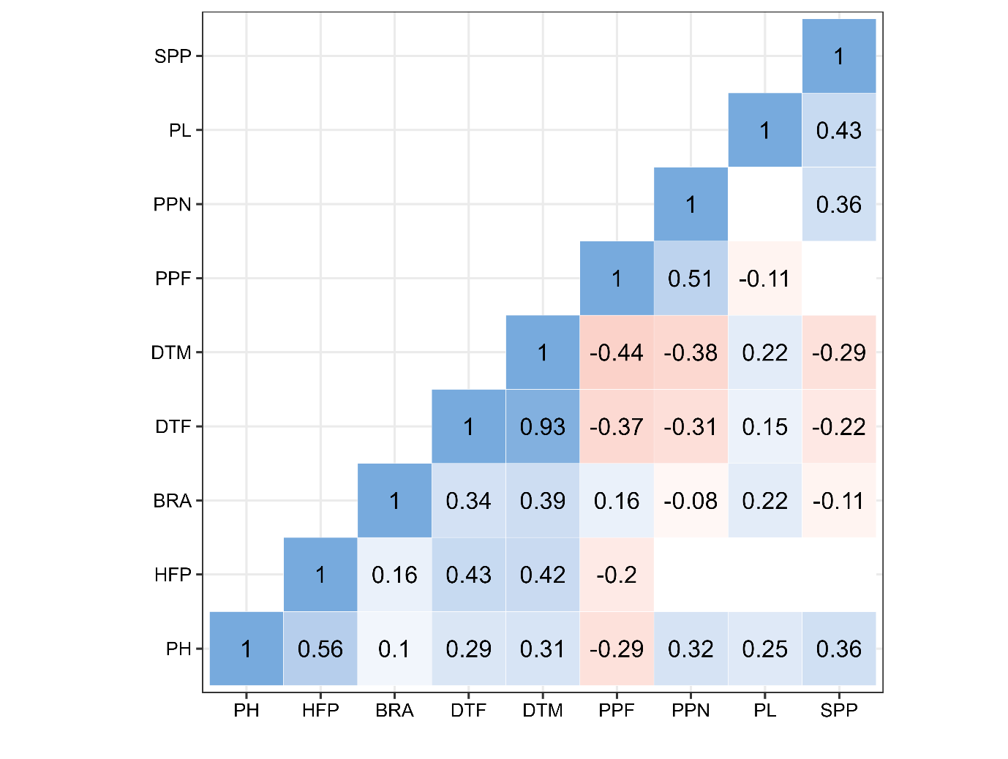

Figure xxx: Correlation between nine traits (PH – Plant height , HFP – Height first pod, BRA – Number of branches, DTF – Days to flower, DTM – Days to mature, PPF – Pods per flower, PPN – Pods per node, SPP – Seeds per pod). The values represent statistically significant correlations at p < 0.01. Blank spaces represent insignificant correlations.

We conducted pairwise correlation analyses among environmnets for each trait (Fig XX). All statisticaly significant correlations were positive except correlation between BO19 and IFC18 for pods per node where we observed moderate negative correlation ( r = -0.53, p < 0.01).

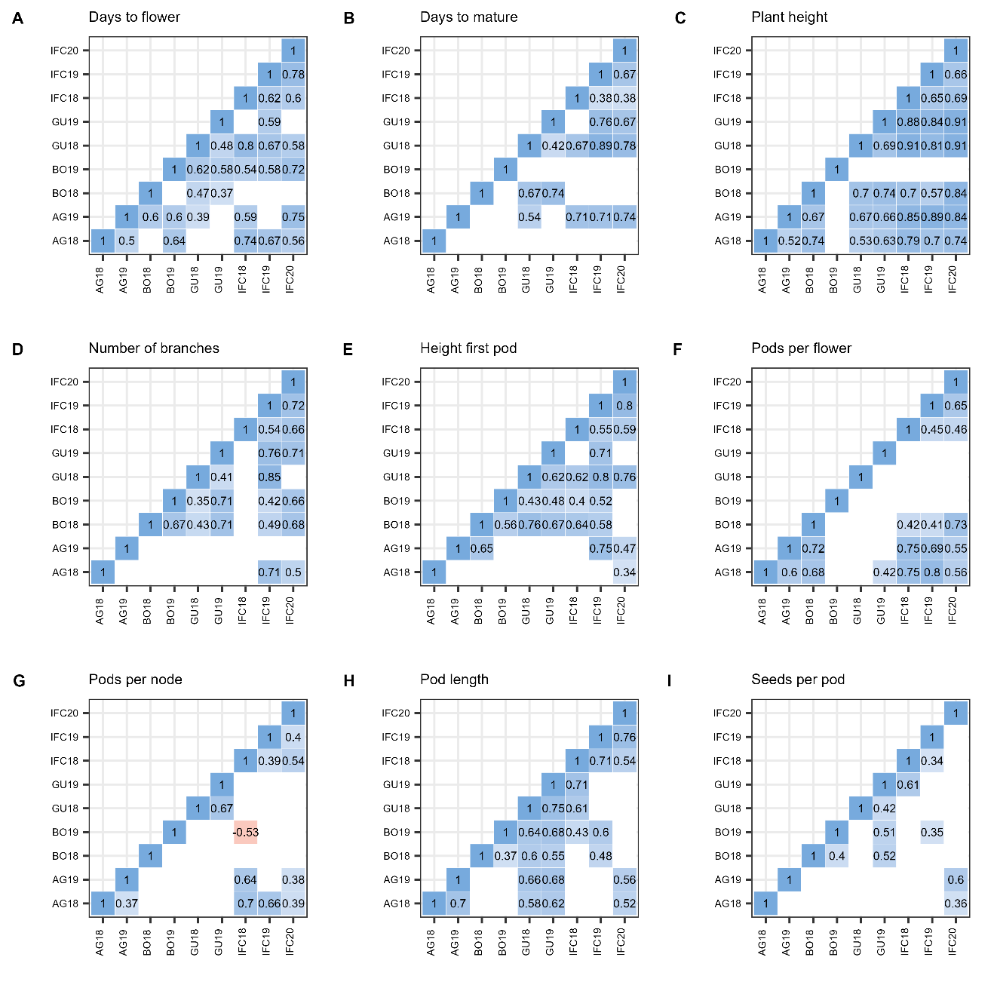

Figure xxx: Pearson parwise correlation coefficient between nine environments for nine trials. Only significant correlations are displayed (p< 0.01)

3.5 GGE Biplot

**Which - won - where patern**

Figure xx shows the Which-won-where view of the GGE biplot pattern for days to flower (Fig xx.A), days to matur (Fig xx.B), plant height (Fig xx.C), number of branches (Fig xx.D), height first pod (Fig xx.E), pods per flower (Fig xx.F), pods per node (Fig xx.G), pod length (Fig xx.H), and seeds per pod (Fig 1.I) and based on 220 genotypes and 9 environments. The first two principal components (PC1 and PC2) of the GGE Biplot explained 46.2%, 39.2%, 52.8%, 46.8%, 48.1%, 41.1%, 40.6%, 52.1% and 37.4% of the variation for DTF, DTM, PH, BRA, HFP, PPF, PPN and SPP, respectively.

The polygon view of the GGE Biplot for days to flower has six sectors delimited by the lines perpendicular to each side of the polygon (Fig. xx.A). The nine environments were grouped into two mega-environments. The first one is formed by IFC18, IFC19, IFC20, AG18 and AG19, where the best genotype is G131, followed by G115, G199 and G100. The second mega-environment is formed by GU18, GU19, BO18 and BO19, where the winning genotype is G126. Note that this sector contains one more vertex of a polygon (G114), but this genotype is winning for the sector located between two sectors, which define two mega-environments.

The same mega-environment pattern was observed for number of branches, height first pod, pods per node and seeds per pod, where 3 environments from Serbia (IFC18, IFC19 and IFC20) and 2 environments from Spain (AG18 and AG19) were grouped into the first mega-environment. These two locations may be referred to as the Southern Europe Mega Environment (SE-ME). The two environments from Belgium and two from Finland were grouped into a second mega-environment, which can be referred to as the North European Mega Environment (NE-ME). For these five trials (DTF, BPP, HFP, PPN and SPP), we constructed two mean vs. stability views of a GGE biplot, one for each mega-environment (Fig. xx).

For number of branches (Fig. xx.D), the winning genotypes were G051 and G063 in SE-ME and NE-ME, respectively. Genotypes with low branches per node in both environments were G171 as well as the four checkers used in the augmented design (Merlin, Fanfare, Mistral and Merkur). The greater high of the first pod was observed  at G100 and G115 for SE-ME, and G126 was the winner at NE-ME, along with G058, G098, G088 and G114 (Fig xx.E). The most pods per node in the SE-ME had G171. Similarly, G029 was the best genotype in terms of pods per node in the NE-ME. (Fig xx.G) The most seeds per pod in SE-ME had G048, while the winner for the second mega-environment was G151 (Fig. xx.I).

Plant height, pods per flower, pod length and days to mature showed no repeatability over the years, so we couldn't divide the target environment into two or more mega-environments. For plant height (Fig. xx.C), environments from Spain and Belgium were in the same sector where the best performer is Merkur, but the environments from Serbia and Spain are mixed up and show no clear year-to-year pattern. For pods per flower (Fig. xx.F), we observed 10 sectors, of which 5 contained one or more environments. For pod length environments, G116 (Fig. xx.H) was the winner in all years in Serbia, while the winners for the rest of the localities were G032 and G064. For days to mature, the winning genotype was Mistral in all environments except BO19 and AG18.

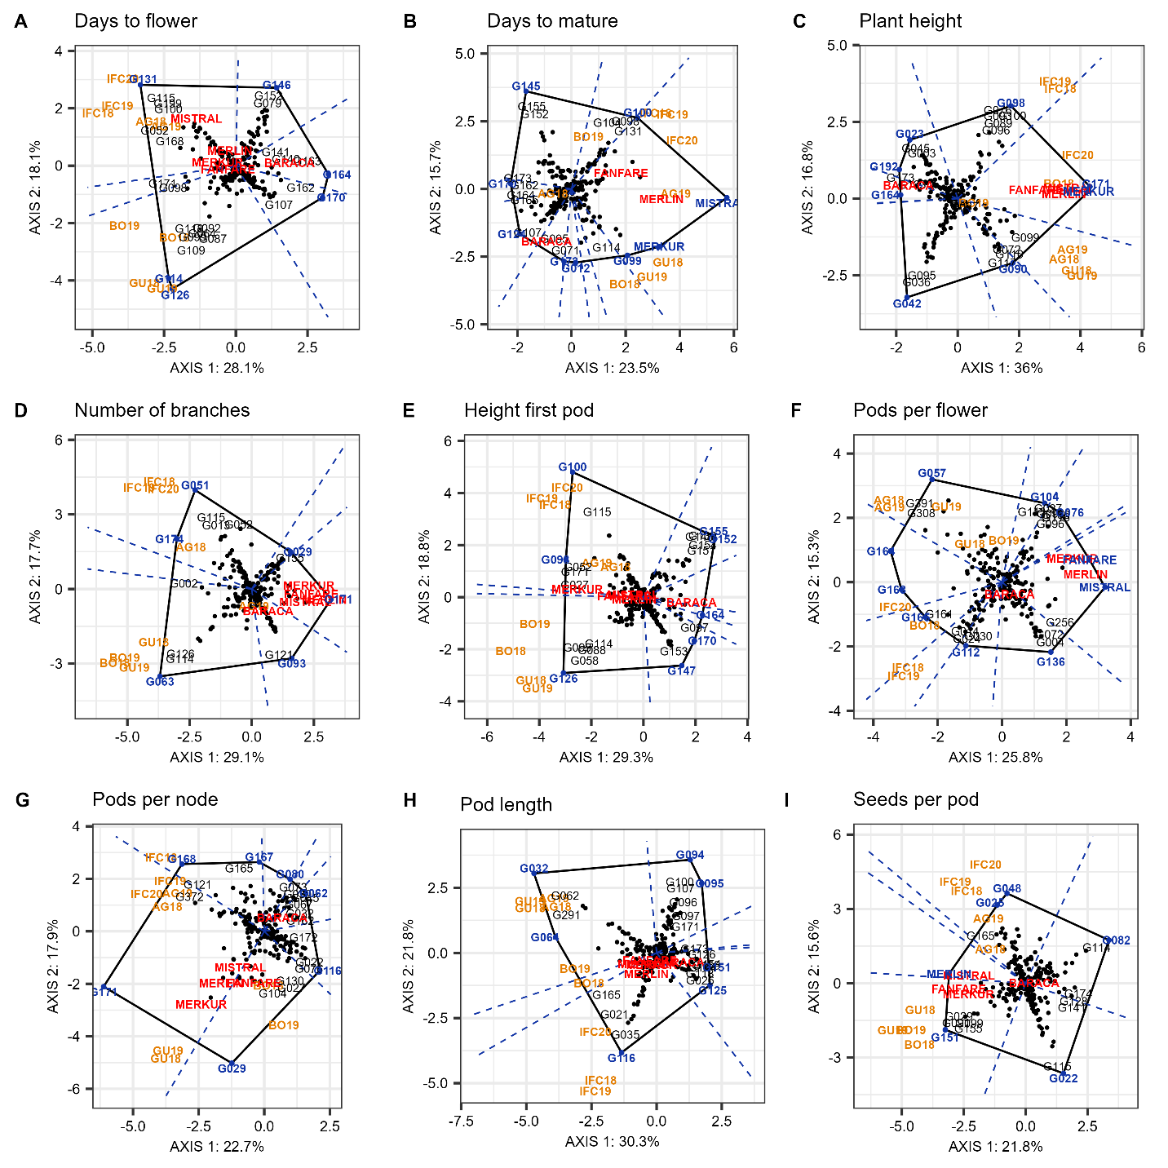

Figure xxx. "Which-won-where" pattern of GGE biplot polygon view displaying the G + GE effect of 220 *Faba bean* genotypes in 9 environments in 4 locations for days to flower (Fig xx.A), days to matur (Fig xx.B), plant height (Fig xx.C), number of branches (Fig xx.D), height first pod (Fig xx.E), pods per flower (Fig 1.F), pods per node (Fig 1.G), pod length (Fig 1.H), and seeds per pod (Fig 1.I). The biplots were based on centering = 0, SVP = 2, and scaling = 0.

**Mean vs. stability patern**

For days to flower, number of branches, height first pod, pods per node and seeds per pod, we observed two mega-environments: the first one formed by locations from Serbia and Spain, namely SE-ME, and the second one formed by two locations from Belgium and Finland (NE-ME). For the remaining four traits (plant height, pods per flower, pod length and days to mature), we couldn't separate four locations into mega-environments since none of these trials shared the best set of genotypes across the years (Yan and Rajcan 2022).

For each mega-environment, we constructed the mean vs. stability (Average Enviroment Condition - AEC) view of a GGE model. The AEC abscissa passes through the ideal environment and the biplot origin. The arrow indicated the greater effect of a genotype component. The AEC ordinate, which is perpendicular to the abscissa and passes through the origin, represents the GxE component with arrows pointing in a direction of greater instability.

For days to flower (Fig. xx.A1, Fig. xx.A2), the "mean vs. stability" pattern revealed 69.8% of G+GxE variation in SE-ME and 69.2% in NE-ME. The longest days to flower in SE-ME had G131, followed by G199, G115, G110, G168 and Mistral. However these genotypes shows great instability. The erliest flowering date on SE-ME had G170, G164 and G162. On NE-ME the latest Days to flower G126, G114, G129. The erliset flowering date had G146.

The greatest number of branches on SE-ME had G051, G174, G115, G013. The smallest number of branches on this ME had G093 and G121.

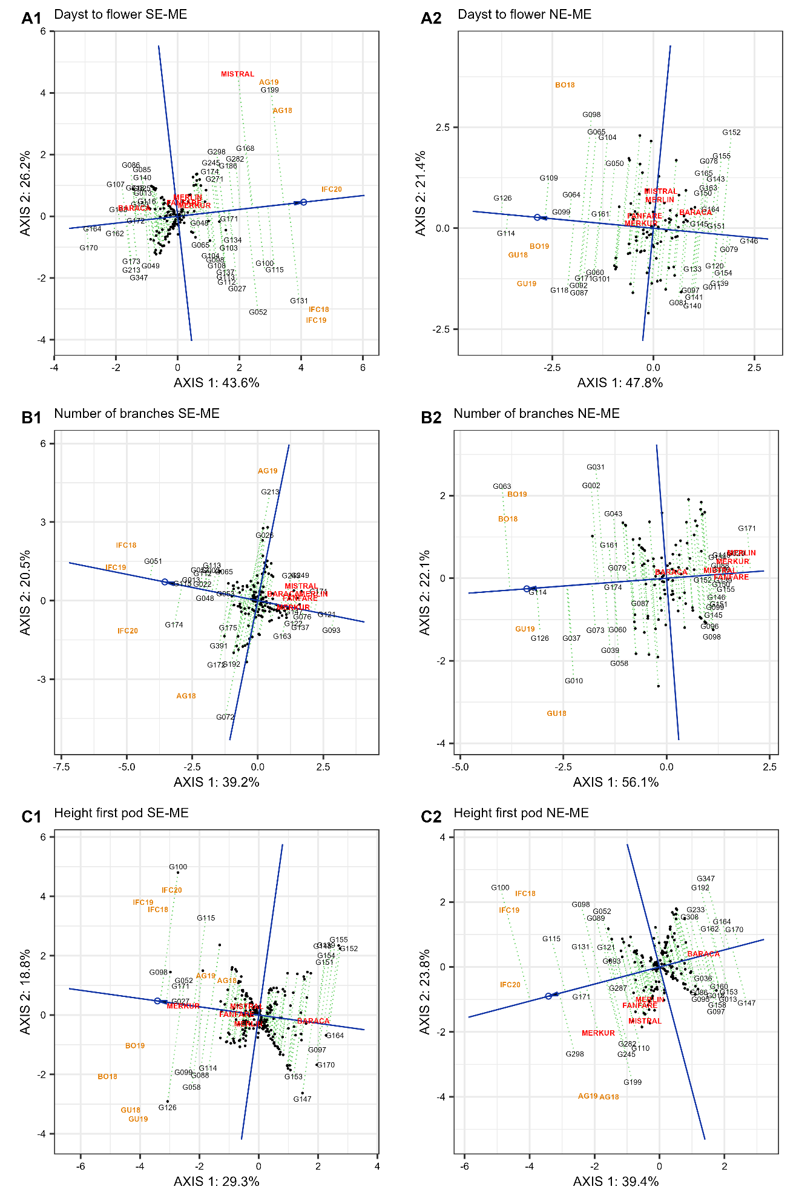

Figure xx. "Mean vs. stability"  pattern for two mega-environments based on 220 *Faba bean* genotypes for days to flower (A1, A2), number of branches (B1, B2) and height first pod (C1, C2). The biplots were based on centering = 0, SVP = 2, and scaling = 0.

Height first pod – nije uradjeno

Pods per node – nije uradjeno

Seeds per pod – nije uradjeno

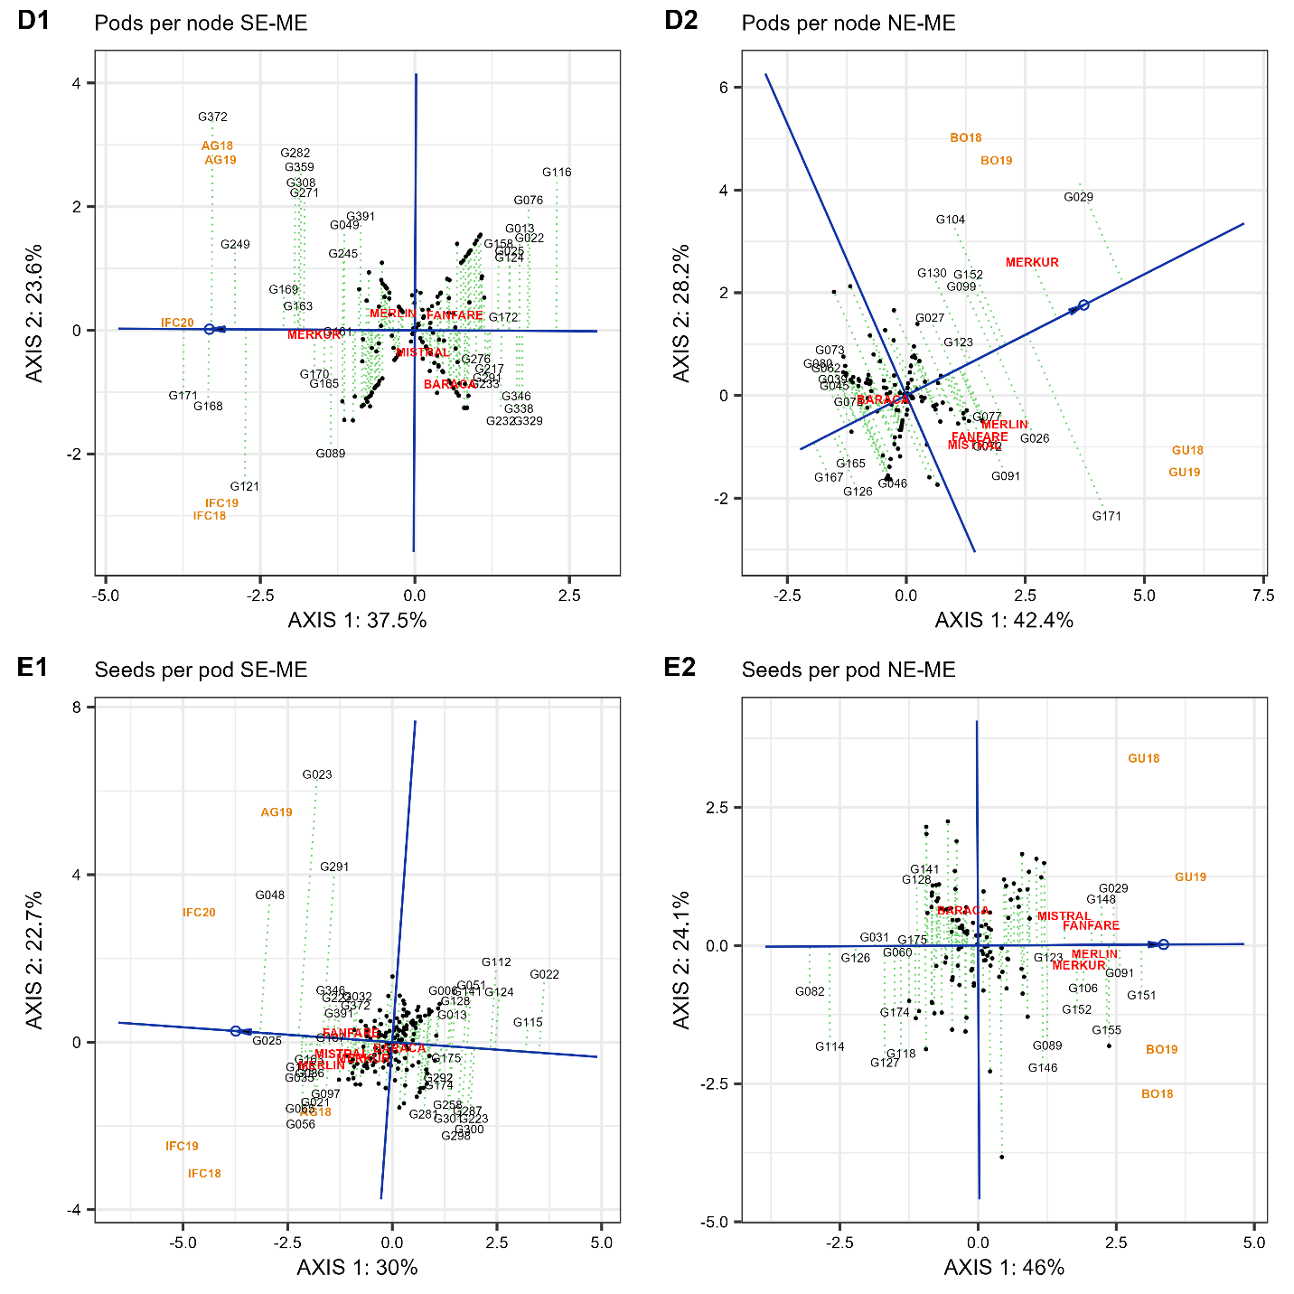

Figure xx. “Mean vs. stability” pattern for two mega-environmnets based on 220 Faba Bean genotypes for pods per node (D1, D2) and seeds per pod (E1, E2). The biplots were based on centering = 0, SVP = 2 and scaling = 0.

For days to mature, plant height, pods per flower and pod length, there was only one mega-environment since there was no repeatable pattern across years. The longest period to mature (Fig. xx.A) had Mistral, followed by Merlin, Merkur, ??, ??, Fanfare. The Misral, Merlin and Fanfare were very stable, unlike other late genotypes. The shortest days to mature (Fig. xx.B) had G170, G173, G162, G164, which were very stable too. For the plant height, genotypes Merkur, Merlin, Mistral, Fanfare and G171 had the highest height, and they were very stable. The shortest plants had G164, along with G192, G173 and Baraca. The genotype ranking in terms of pods per flower (Fig. xx.C) was G164 > G163 > G391 > G308 > G057, but the latest three showed great instability. The smaller number of pods per flower had Mistarl (which was very stable), followed by Merlin Fanfare, Merkur and G256. The longest pods had G064 followed by G032, G291, G062, G165.

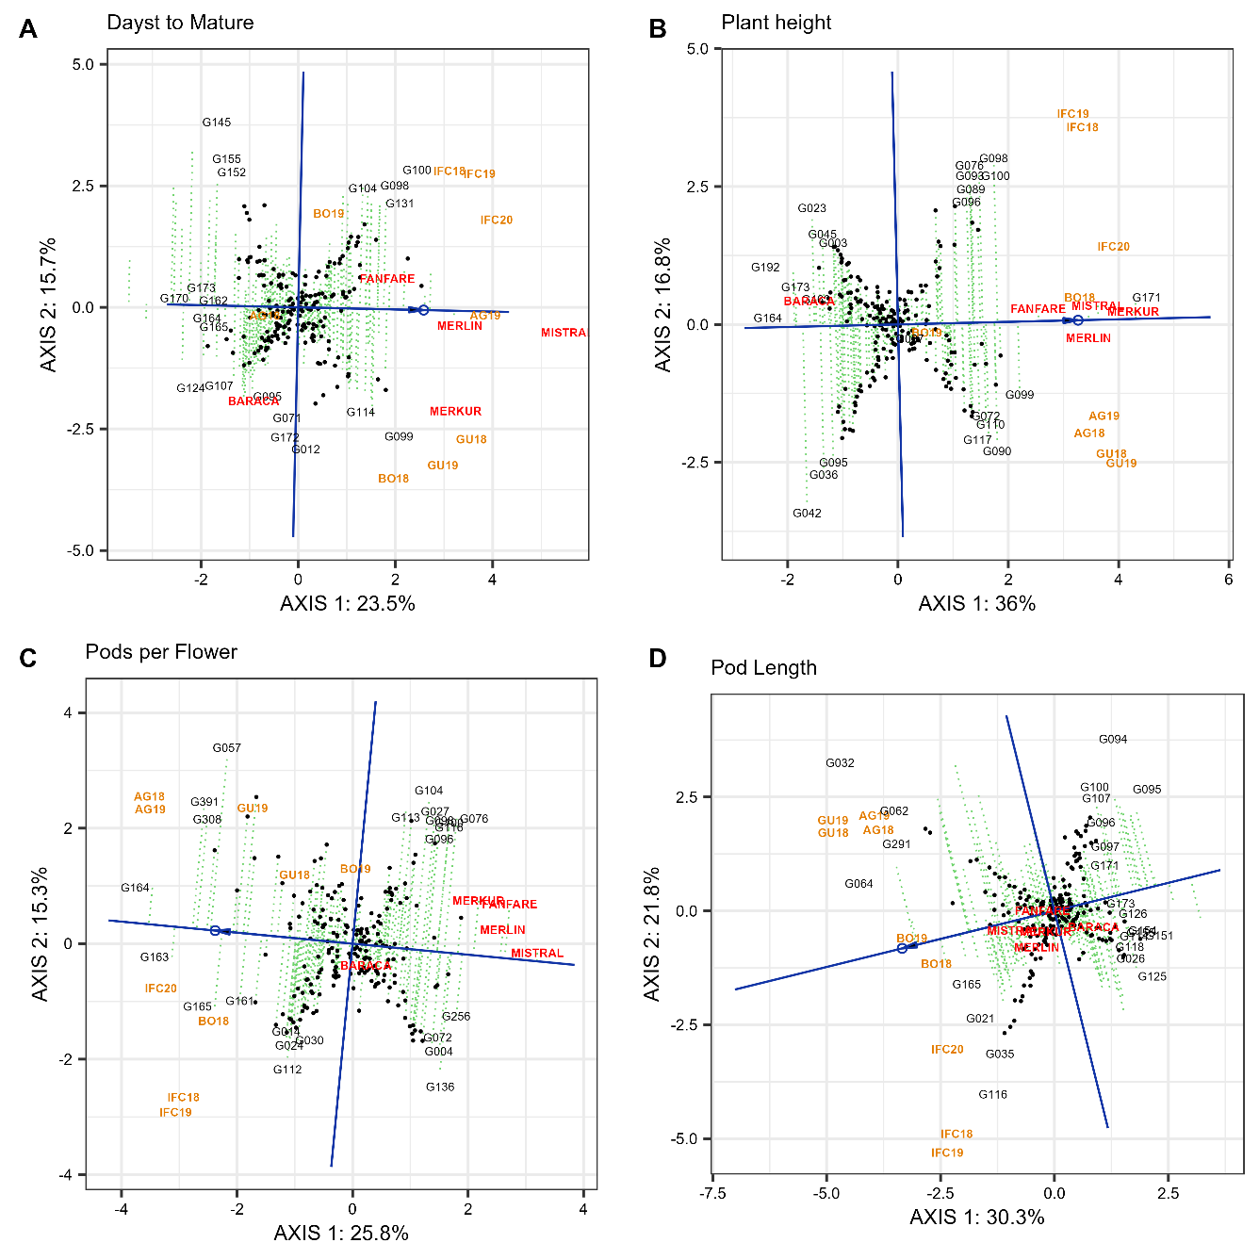

Figure xx. "Mean vs. stability"  pattern of GGE biplot based on 220 Faba Bean genotypes in 9 environments in 4 locations for days to mature (Fig xx.A), plant height (Fig xx.B), pods per flower (Fig xx.C) and pod length (Fig xx.D). The biplots were based on centering = 0, SVP = 2, and scaling = 0.

3.6 Cluster Analysis

Hierarchical cluster analysis (HCA) was constructed to illustrate the disimilarities among the different genotypes in terms of phenotypic traits with a varying intensity of magenta (low) to green (high) color (Fig. xxx). The 220 genotypes were grouped into two major clusters, where the first cluster (I) contained four subclusters: A, B, C and D, and the second major cluster (II) had three subclusters: E, F and G. Subcluster B had the maximum number of accessions (71). Other subclusters consist of a lower number of accessions: A (56), C (28), D (19), E (26), F (6) and G (14).

The two major clusters are distinguished by four traits: days to flower, height of first pod, days to mature and plant height, such that the first major cluster (I) is characterized by lower values of these four traits. Subclaster B gathers accessions with the earliest flowering, earliest maturity date and smallest height of first pod. Cluster A also had small values of all four traits that distinguish between major clusters. On the other hand, subcluster D contains genotypes with largest number of pods per flower, and subcluster C has the longest pod length. The second major cluster, having three sub-clusters (E, F and G), is characterized by high values for days to flower, days to mature, height of first pod and plant height. Cluster F had the latest flowering days, laregest height of first pod, while cluster G had late maturity days. Subcluster E contains genotypes with highest plants, largest number of pods per node and the largest number of seeds per pod. On the other hand, cluster G had the smallest number of pods per flower, cluster F had the smallest pod length and cluster E had the smallest number of branches (Supplementary Table Sxxx).

The average diameter distance showed that the most diverse cluster is G (dist = 3.17) and the most compact cluster is C (d = 2.92). The average linkage distance showed that the maximum inter-cluster distance is between clusters A and G (d = 5.87). The smallest inter-cluster distance in major cluster (I) was observed between A and B (dist = 3.45) and in major cluster (II) the smallest distance was between E and G (dist = 3.90) (Supplementary Table Sxxx).

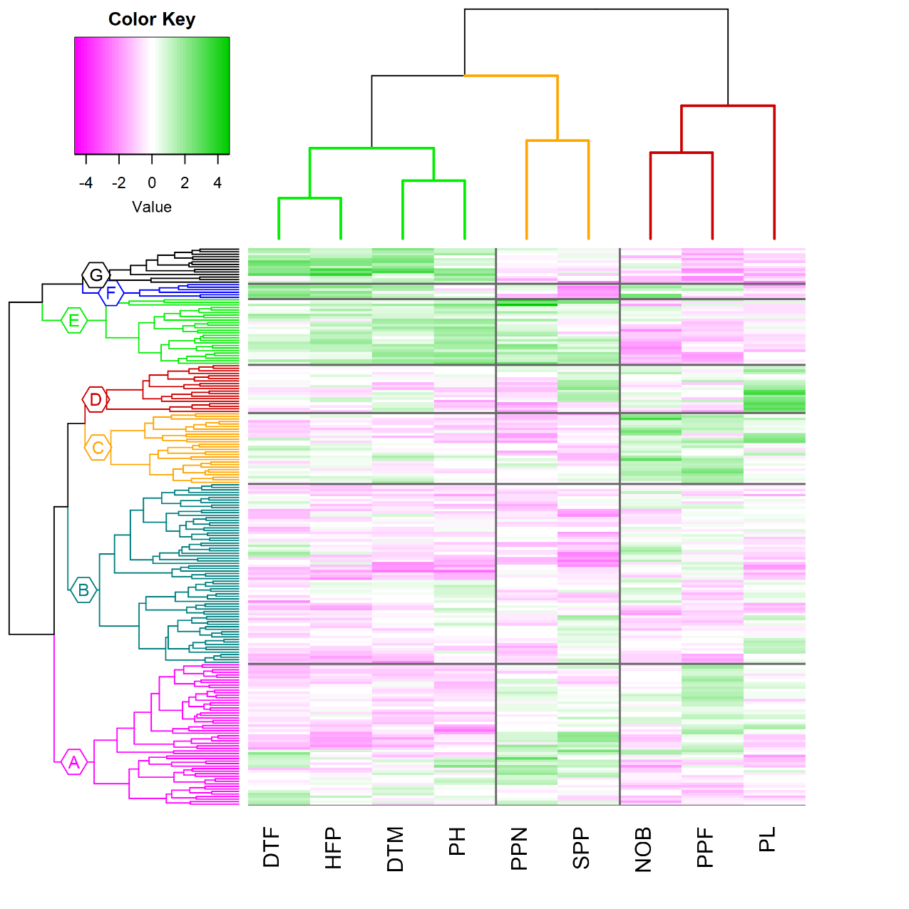

Fig xx; Hierarchical Cluster Analysis of 220 genotypes constructed based on BLUP-s, using euclidean distance and complete linkage clustering method with heatmap showing phenotypic traits (DTF – days to flower, HFP – height of first pod, DTM – days to mature, PH – plant height, PPN – pods per node, SPP – seeds per pod, NOB – number of branches, PPF – Pods per flower and PL – pod length).

**Tabela xxx**: Sub-clusters with percentage of botanical types and precent of botanical type in whole collection.

|  |  |  |  |  |  |  |  |  |
| --- | --- | --- | --- | --- | --- | --- | --- | --- |
|  | A | B | C | D | E | F | G | whole collection |
| Paucijuga | 13 | 1 | 0 | 0 | 4 | 0 | 7 | 5 |
| Minor | 18 | 21 | 0 | 4 | 65 | 17 | 71 | 25 |
| Equina | 48 | 48 | 32 | 50 | 19 | 33 | 14 | 41 |
| Major | 11 | 10 | 47 | 46 | 4 | 17 | 0 | 17 |
| Unknown | 11 | 20 | 21 | 0 | 8 | 33 | 7 | 13 |

Celokupna kolekcija je u odnosu na osobine semena podeljena na četiri grupe, na delu podataka nedostaju informacije o botaničkom tipu tako da su ti podaci označeni kao Unknown. Kod većine pod klastera javljaju se svi botanički tipovi ali je njihov udeo različit. U pod klasteru A koji se karakteriše ranim cvetanjem i manjom visinom biljaka najzastupljeniji su genotipovi Equina tipa. Isti botanički tip dominira i u podklasterima B (48%) i D (58%) koji su deo Clastera I koji se izdvaja zbog nižih vrednosti osobina (DTF, BRA, PH, SPP). Za klaster II i pod klastere E i G karakteristična je zastupljenost minor typa (56% i 63%). U pod klasteru C gde su grupisani genotipovi najdužih mahuna seme je malih dimenzija i pripada minor i paucijuga tipu. U celokupnoj kolekciji najzastupljeniji je Equina tip semena i 41% genotipova se odlikuje ovakvim semenom. Nakon toga slede Minor genotipovi sa 25% i Major sa 17%. Mali deo kolekcije čine genotipvi paucijuga tipa, samo 5%.

3.7 Principal components analysis

Principal component analysis of the nine phenotypic traits showed that the first two PCs were able to explain 56.4% of the variability in 220 genotypes (Fig. xxx). Table xxx shows the eigenvalues and proportion of variation for the first three PCA loadings.

PC1 accounted for 37% of the total variance observed. It was strongly related to plant height, days to mature, height of first pod and pods per flower. The first PC is inversly related to pods per flower and pod length. PC2 (which accounted for 19.8% of variance) was positively related to seeds per pod and negatively related to the number of branches. PC3 explained 13.7% of variation and was positively loaded by pods per flower and pods per node and negatively loaded by pod length.

Table xxx.  The first three principal component scores for agronomic traits

|  |  |  |  |
| --- | --- | --- | --- |
|  | PC1 | PC2 | PC3 |
| Eigenvalue | 1.82 | 1.34 | 1.111 |
| Proportion of variation | 36.6 | 19.8 | 13.7 |
| Component loadings |  |  |  |
| DTF | **0.38** | -0.36 | 0.09 |
| DTM | **0.44** | -0.16 | -0.22 |
| PH | **0.47** | 0.12 | -0.07 |
| NOB | -0.19 | **-0.57** | 0.01 |
| HFP | **0.44** | -0.31 | -0.03 |
| PPF | **-0.30** | -0.16 | **0.46** |
| PPN | 0.25 | 0.34 | **0.51** |
| PL | **-0.21** | -0.01 | **-0.66** |
| SPP | 0.08 | **0.52** | -0.20 |

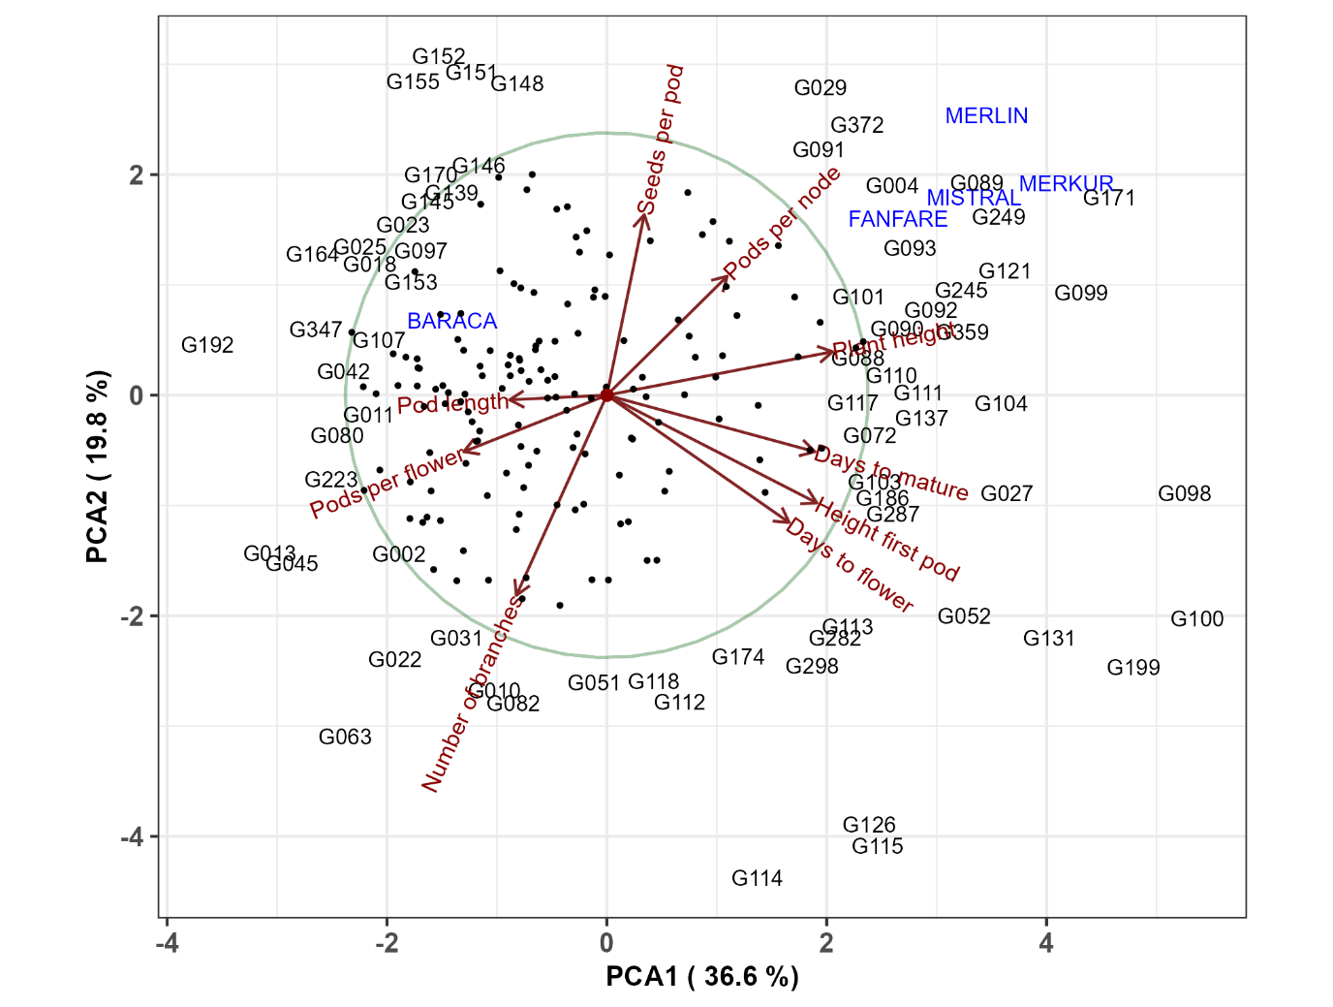

Figure xxx. Principal component analysis of 220 Faba bean genotypes and 9 phenotypic traits Genotypes were represented with eather its name or with dots.

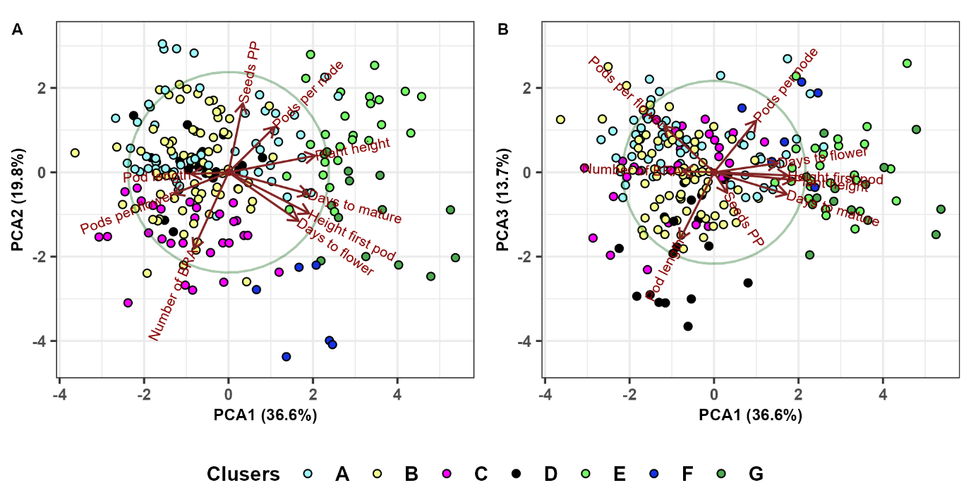

Figure xxx. Principal component analysis of 220 Faba bean genotypes and 9 phenotypic traits shows results of hierarchical clustering analysis. Cluster names are as in section 3.3.

We used principal component analysis (Fig. xxx) to confirm and further explain the results obtained in hierarchical clustering analysis in section 3.3. Fig. xxx.A shows that the first PCA clearly separates the first major cluster containing subclusters A,B,C and D from the second major cluster containing subclusters E, F and G. Cluster G contains late genotypes with a large height of first pod and cluster E contains tall plants with large number of pods per node. Clusters A and B contain early genotypes with small heights. Cluster C is characterized by a large number of branches. The third PCA axis (Fig. xxx.B) separates cluster D, which has a high pod length, from clusters A, B and C.

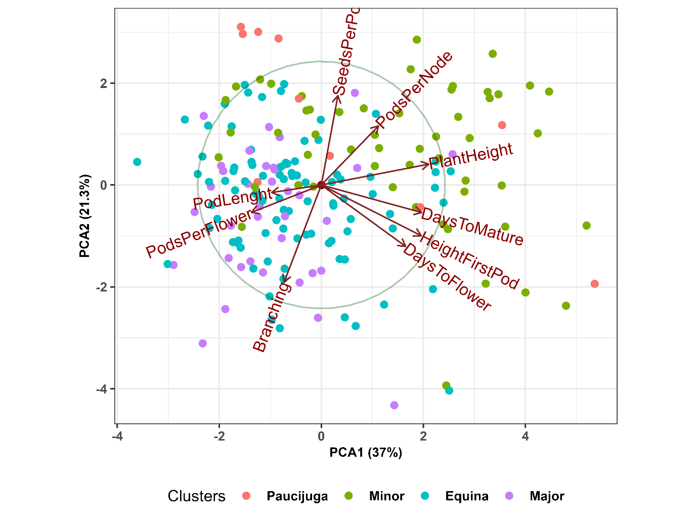

Figure xx. Principal component analysis based on 191 *Faba bean* genotypes shows relations between nine agronomic traits and four botanical types. The analysis included genotypes with known botanical types.

We also used principal component analysis to visualize the relationship between nine phenotypic traits and four botanical types. PCA results showed that the botanical types Equina and Major are characterized by a larger plant height, a larger number of pods per flower and a larger number of branches, while Minor is characterized by the remaining six traits. This supports the conclusions about botanical types that we were obtained in section 3.3.

4. Diskusija

This research describe colection of 220 faba bean accessions, acrosse four representative European regions and 9 environments. Primena augmentativnog dizajna u zasnivanju ogleda omogućava da se ispita velika kolekcija kako bi se materijal što efikasnije uključio u dalje faze oplemenjivanja. Detaljna fenotipska karakterizacija je preduslov ovog procesa (citat crvena eukleg). Ukoliko se ovakav dizajn primeni u više environmenta izdvajaju se prinosni i stabilni genotipovi koji se uspešno mogu gajiti na širem prostoru. Up to now faba bean remains important plant species as source of proteins in grains, high-yield potential and as forage and cover crop (Maalouf et al., 2018). Iz tog razloga izdvajanje prinosnih i stabilnih genotipova je neophodno kako bi se povećalo učešće ove vrste u biljnoj proizvodnji. Najznačajnija stavka u zasnivanju ogleda kada je bob u pitanju je odgovarajuće vreme: dovoljno vlage u zemljištu, kao i hladniji period godine. Zasnivanje svih 9 ogleda je bilo uspešno.

Fenološke osobine kao što je vreme cvetanja i vreme sazrevanja su vrlo značajne za određivanje krajnjeg prinosa (Etemadi et al., 2018). Iako je za bob značajno da početni razvoj bude u hladnijem delu godine, tokom čitavog vegetacionog ciklusa potrebne su padavine kako bi ukupan biološki prinos ove vrste bio odgovarajući. Environment IFC19 odlikovao se prosečno višim temperaturama i manjom vrednošću padavina u poređenju sa IFC18 i IFC20. Tako da je prosečno vreme sazrevanja bilo kraće (oko 80 dana), to je uticalo na prosečno slabije grananje biljaka na IFC19. Produženi razvoj kome su bili izloženi genotipovi na prostoru Španije usled jesenjeg zasnivanja (prosečno vreme sazrevanja je dvostruko duže u poređenju sa drugim lokalitetima) doveo je do razvoja velikog broja bočnih grana, maksimalna vrednost na AG18 bila je 13 bočnih grana. Sezone (environment) 2018 i 2019 u Španiji su se međusobno razlikovale po količini padavina, tako da je period izvođenja ogleda AG18 sa skoro dvostruko manje padavina u poređenju sa AG19 (Tabela...). Veća količina padavina u AG19 je dovela do najviših prosečnih vrednosti visine biljaka (93 cm) ali i maksimalnih vrednosti od 154 cm što je tri puta više u poređenju sa BO19 (48 cm). Ovako izražen razvoj nadzemnog dela, okarakterisan velikom visinom i razvojem bočnih grana nije pozitivno uticao na komponente prinosa semena. Tako da su AG18 i AG19 zajedno sa BO19 environmenti sa najnižim vrednostima: number of pods per flower and number of pods per node, dok je broj semenki po mahuni imao slične vrednosti kao na drugim lokalitetima. Ovo je u saglasnosti sa radom Pilbeam et al., 1990, koji navode da su bočne grane reproduktivno inferiorne u poređenju sa glavnim stabljikama; dok Tuttobene and Vagliasindi (1995) navode da pri velikoj gustini dolazi do opadanja mahuna. Sa povećanjem gustine number of pods per node decrease (Barry and Storey, 1979).

5. Reference

de Visser, C., Schreuder, R., & Stoddard, F. (2014). The EU's dependence on soya bean import for the animal feed industry and potential for EU produced alternatives. Oilseeds and fats, crops and lipids.

Mínguez, M. I., & Rubiales, D. (2021). Faba bean. In V. O. Sadras & D. F. Calderini (Eds.), Crop Physiology Case Histories for Major Crops (pp. 452–481). Academic Press. https://doi.org/10.1016/B978-0-12-819194-1.00015-3

Bilalis, D., Sidiras, N., Economou, G., and Vakali, C. (2003). Effect of different levels of wheat straw soil surface coverage on weed flora in Vicia faba crops. J. Agron. Crop Sci. 189, 233–241. doi: 10.1046/j.1439-037X.2003.00029.x

Rubiales, D. (2010). Faba beans in sustainable agriculture. Field Crops Res. 115, 201–202. doi: 10.1016/j.fcr.2009.11.002

Dhull, S. B., Kidwai, M. K., Noor, R.,Chawla, P., & Rose, P. K. (2022). A review of nutritional profileand processing of faba bean (Vicia fabaL.).Legume Science,4(3), e129.https://doi.org/10.1002/leg3.129DHULLET AL.13 of 13 - A

Cubero JI. On the evolution of Vicia faba L. Theor Appl Genet. 1974 Jan;45(2):47-51. doi: 10.1007/BF00283475. PMID: 24419274.

Duc, G., Aleksić, J. M., Marget, P., Mikic, A., Paull, J., Redden, R. J., ... & Torres, A. M. (2015). Faba bean. Grain legumes, 141-178.

Caracuta, V., Barzilai, O., Khalaily, H. et al. The onset of faba bean farming in the Southern Levant. Sci Rep 5, 14370 (2015). https://doi.org/10.1038/srep14370

Caracuta, V., Weinstein-Evron, M., Kaufman, D. et al. 14,000-year-old seeds indicate the Levantine origin of the lost progenitor of faba bean. Sci Rep 6, 37399 (2016). https://doi.org/10.1038/srep37399

Suso, M.J. and Cubero J.I. (1986). Genetic changes under domestication in Vicia faba. Theoretical and Applied Genetics 72, 364–372

Torres AM, Avila CM, Stoddard FL, Cubero JI (2012)Faba bean. In: (Vega MP de la (ed). Genetics, Genomicsand Breeding of cool season grain legumes. SciencePublishers, Hampshire, p 50-97.

Zong X, Liu X, Guan J, Wang S, Liu Q, Paull JG, Redden R (2009a)Molecular variation among Chinese and global winter faba beangermplasm. Theor Appl Genet 118:971–978

JI Cubero (2011) The faba bean: A historic perspective. Grain Legumes No 56, April 2011

Johnson, R., Johnston, W., Nelson, M., Simon, C., and Golob, C. (1999). “Core utilization and development–an example with Poa pratensis,” in Core Collections for Today and Tomorrow, eds R. C. Johnson and T. Hodgkin (New York, NY: Plant Genetic Resources Institute), 49–60.

Maalouf, Fouad & Suso, M. & Moreno, M.T.. (2002). Comparative performance of faba bean synthetics developed from different parental number. Journal of Genetics and Breeding. 56. 251-258.

Suso, M. J. & Moreno, M. T. (1999). Variation in out-crossing rate and genetic structure on six cultivars of Viciafaba L. as affected by geographic location and year. PlantBreeding 118, 347

Gnanasambandam, A.; Paull, J.; Torres, A.; Kaur, S.; Leonforte, T.; Li, H.; Zong, X.; Yang, T.; Materne, M. Impact of Molecular Technologies on Faba Bean (Vicia faba L.) Breeding Strategies. Agronomy 2012, 2, 132-166. https://doi.org/10.3390/agronomy2030132

Karkanis, A., Ntatsi, G., Lepse, L., Fernández, J. A., Vågen, I. M., Rewald, B., ... & Savvas, D. (2018). Faba bean cultivation–revealing novel managing practices for more sustainable and competitive European cropping systems. Frontiers in plant science, 1115.

Dhull, S.B., Kidwai, M.K., Siddiq, M. and Sidhu, J.S. (2022). Faba (Broad) Bean Production, Processing, and Nutritional Profile. In Dry Beans and Pulses (eds M. Siddiq and M.A. Uebersax). https://doi.org/10.1002/9781119776802.ch14 - B

Meng Z, Liu Q, Zhang Y, Chen J, Sun Z, Ren C, Zhang Z, Cheng X, Huang Y. Nutritive value of faba bean (Vicia faba L.) as a feedstuff resource in livestock nutrition: A review. Food Sci Nutr. 2021 Jul 22;9(9):5244-5262. doi: 10.1002/fsn3.2342. PMID: 34532032; PMCID: PMC8441412.

Duc, 1997 Faba bean (Vicia faba L.) Field Crops Research, 53 (1) (1997), pp. 99-109, 10.1016/S0378-4290(97)00025-7

Koivunen, E.; Partanen, K.; Perttilä, S.; Palander, S.; Tuunainen, P.; Valaja, J., 2016. Digestibility and energy value of pea (Pisum sativum L.), faba bean (Vicia faba L.) and blue lupin (narrow-leaf) (Lupinus angustifolius) seeds in broilers. Anim. Feed Sci. Technol., 218: 120-127

USDA (US Dept of Agriculture). (2021). Food Data Central (Nutrient Database). https://fdc.nal.usda.gov/ (accessed on January 26, 2021).

Pietrzak, W., Kawa-Rygielska, J., Król, B., Lennartsson, P. R., & Taherzadeh, M. J. (2016). Ethanol, feed components and fungal biomass production from field bean (Vicia faba var. equina) seeds in an integrated process. Bioresource Technology, 216, 69-76.

Reinhard Neugschwandtner, Katja Ziegler, Simon Kriegner, Helmut Wagentristl & Hans-Peter Kaul (2015) Nitrogen yield and nitrogen fixation of winter faba beans, Acta Agriculturae Scandinavica, Section B — Soil & Plant Science, 65:7, 658-666, DOI: 10.1080/09064710.2015.1042028

Salahin N, Alam MK, Islam MM, Naher L, Majid NM 2013. Effectds of green manure nad tillage practice onmaize and rice yields and soil properties. Australian Journal of Crop Science 7(12): 1901-1911

Hauggaard-Nielsen, H., Jørnsgaard, B., Kinane, J., & Jensen, E. (2008). Grain legume–cereal intercropping: The practical application of diversity, competition and facilitation in arable and organic cropping systems. Renewable Agriculture and Food Systems, 23(1), 3-12. doi:10.1017/S1742170507002025

FERNÁNDEZ-APARICIO, M., GARCÍA-GARRIDO, J.M., OCAMPO, J.A. and RUBIALES, D. (2010), Colonisation of field pea roots by arbuscular mycorrhizal fungi reduces Orobanche and Phelipanche species seed germination. Weed Research, 50: 262-268. https://doi.org/10.1111/j.1365-3180.2010.00771.x

Mónica Fernandez-Aparicio, Josefina C. Sillero, Diego Rubiales, Intercropping with cereals reduces infection by Orobanche crenata in legumes, Crop Protection, Volume 26, Issue 8, 2007, Pages 1166-1172, https://doi.org/10.1016/j.cropro.2006.10.012.

Alghamdi, S.S., Migdadi, H.M., Ammar, M.H. et al. Faba bean genomics: current status and future prospects. Euphytica 186, 609–624 (2012). https://doi.org/10.1007/s10681-012-0658-4

Flores, F., Hybl, M., Knudsen, J. C., Marget, P., Muel, F., Nadal, S., ... & Rubiales, D. (2013). Adaptation of spring faba bean types across European climates. Field Crops Research, 145, 1-9.

Cernay, C., Ben-Ari, T., Pelzer, E., Meynard, J. M., & Makowski, D. (2015). Estimating variability in grain legume yields across Europe and the Americas. Scientific reports, 5(1), 11171.

Temesgen, T., Keneni, G., Sefera, T., & Jarso, M. (2015). Yield stability and relationships among stability parameters in faba bean (Vicia faba L.) genotypes. The crop journal, 3(3), 258-268.

Rowlands, D. G. (1960). Fertility studies in the field bean Vicia faba L.). 1. Cross and self-fertility. Heredity, 15, 161-73.

O'Sullivan, D. M., & Angra, D. (2016). Advances in faba bean genetics and genomics. Frontiers in genetics, 7, 150.

Crépon, K., Marget, P., Peyronnet, C., Carrouée, B., Arese, P., & Duc, G. (2010). Nutritional value of faba bean (Vicia faba L.) seeds for feed and food. Field crops research, 115(3), 329-339.

Duc, G. ; Bao ShiYing ; Baum, M. ; Redden, B. ; Sadiki, M. ; Suso, M. J. ; Vishniakova, M. ; Zong XuXiao Diversity maintenance and use of Vicia faba L. genetic resources. Field Crops Research 2010 Vol.115 No.3 pp.270-278 ref.many Field Crops Research 2010 Vol.115 No.3 pp.270-278 ref.many

Palmer, R. G., Gai, J., Dalvi, V. A., & Suso, M. J. (2011). Male sterility and hybrid production technology. In Biology and breeding of food legumes (pp. 193-207). Wallingford UK: CABI.

Gasim, S., & Link, W. (2007). Agronomic performance and the effect of self-fertilization on German winter faba beans. Journal of Central European Agriculture, 8(1), 121-128.

Liu and Hou, 2010, Genetic Diversity of Faba Bean Germplasms in Qinghai and Core Germplasm Identified based on AFLP Analysis, Legume Genomics and Genetics Vol.1 No.1 (doi:10.5376/lgg.2010.01.0001)

Zeid, M., Schön, C. C., & Link, W. (2003). Genetic diversity in recent elite faba bean lines using AFLP markers. Theoretical and Applied Genetics, 107, 1304-1314.

Oliveira, H. R., Tomás, D., Silva, M., Lopes, S., Viegas, W., & Veloso, M. M. (2016). Genetic diversity and population structure in Vicia faba L. landraces and wild related species assessed by nuclear SSRs. PloS one, 11(5), e0154801.

Göl, Ş., Doğanlar, S., & Frary, A. (2017). Relationship between geographical origin, seed size and genetic diversity in faba bean (Vicia faba L.) as revealed by SSR markers. Molecular Genetics and Genomics, 292, 991-999.

Kaur, S., Kimber, R. B., Cogan, N. O., Materne, M., Forster, J. W., & Paull, J. G. (2014). SNP discovery and high-density genetic mapping in faba bean (Vicia faba L.) permits identification of QTLs for ascochyta blight resistance. Plant Science, 217, 47-55.

Sallam, A., Arbaoui, M., El-Esawi, M., Abshire, N., & Martsch, R. (2016). Identification and verification of QTL associated with frost tolerance using linkage mapping and GWAS in winter faba bean. Frontiers in Plant Science, 7, 1098.

Elshafei, A. A. M., Amer, M. A. E., Elenany, M. A. M., & Helal, A. G. A. E. (2019). Evaluation of the genetic variability of faba bean (Vicia faba L.) genotypes using agronomic traits and molecular markers. Bulletin of the National Research Centre, 43(1), 1-10.

Carrillo-Perdomo, E., Vidal, A., Kreplak, J., Duborjal, H., Leveugle, M., Duarte, J., ... & Aubert, G. (2020). Development of new genetic resources for faba bean (Vicia faba L.) breeding through the discovery of gene-based SNP markers and the construction of a high-density consensus map. Scientific Reports, 10(1), 6790.

Massicotte P, South A (2023). rnaturalearth: World Map Data from Natural Earth. R package version 0.3.2, https://CRAN.R-project.org/package=rnaturalearth.

Leo Lahti, Janne Huovari, Markus Kainu, Przemyslaw Biecek. Retrieval and analysis of Eurostat open data with the eurostat package. R Journal 9(1):385-392, 2017. doi: 10.32614/RJ-2017-019 Package URL: http://ropengov.github.io/eurostat Article URL: https://journal.r-project.org/archive/2017/RJ-2017-019/index.html

R Core Team (2022). R: A language and environment for statistical computing. R Foundation for Statistical Computing, Vienna, Austria. URL https://www.R-project.org/.

Liu, Xu-Qing; Rong, Jian-Ying; Liu, Xiu-Ying (2008). "Best linear unbiased prediction for linear combinations in general mixed linear models". Journal of Multivariate Analysis. 99 (8): 1503–1517. doi:10.1016/j.jmva.2008.01.004.

Harrell Jr F (2023). Hmisc: Harrell Miscellaneous. R package version 5.0.1, https://CRAN.R-project.org/package=Hmisc.

Kassambara A (2022). ggcorrplot: Visualization of a Correlation Matrix using 'ggplot2'. R package version 0.1.4, https://CRAN.R-project.org/package=ggcorrplot.

Gabriel K.R. (1971): The biplot graphic display of matrices with application to principal component analysis. Biometrika 58(3): 453-467.

Yan W and Hunt LA, Sheng Q and Szlavnics Z, 2000. Cultivar evaluation and mega-environment investigation based on GGE biplot. Crop Science 40: 596–605

Gauch H.G. (2006): Statistical analysis of yield trials by AMMI and GGE. Crop Science 46: 1488-1500.

Hongyu K., Penña M.G., Araújo L.B., Dias C.T.S. (2014): Statistical analysis of yield trials by AMMI analysis of genotype × environment interaction. Biometrical Letters 51(2): 89-102.

Yan, W., and L.A. Hunt. 2002. Biplot analysis of diallel data. Crop Sci. 42:21–30.

Yan, W., and I. Rajcan. 2002. Biplot evaluation of test sites and trait relations of soybean in Ontario. Crop Sci. 42:11–20.

Yan, W. 2001. GGEBiplot—A Windows application for graphical analysis of multi-environment trial data and other types of two-way data. Agron. J. 93:1111–1118.

Yan W, Kang MS (2003) GGE Biplot Analysis: A graphical tool for breeders, geneticists, and agronomists. CRC Press, Boca Raton, FL.

Yan W, Kang MS, Ma B,Woods S, Cornelius PL (2007) GGE biplot vs. AMMI analysis of genotype-by environment data. Crop Sci. 47: 643-655.

Tal Galili (2015). dendextend: an R package for visualizing, adjusting, and comparing trees of hierarchical clustering. Bioinformatics. DOI: 10.1093/bioinformatics/btv428

Warnes G, Bolker B, Bonebakker L, Gentleman R, Huber W, Liaw A, Lumley T, Maechler M, Magnusson A, Moeller S, Schwartz M, Venables B (2022). gplots: Various R Programming Tools for Plotting Data. R package version 3.1.3, https://CRAN.R-project.org/package=gplots.

Nieweglowski L (2020). clv: Cluster Validation Techniques. R package version 0.3.2.2, https://CRAN.R-project.org/package=clv.